MODEL ANSWER FOR ‘UNKEPT PROMISES’ (UA Pilots)

Summary of case:

The US labor dept. filings by UA ‘showed’ that the ‘pilots retirement trust’ was well funded. However, a report to investors wrote that in 2002 the trust had only half the needed assets. Govt Accounting rules for (valuing or costing) corporate pensions and the PGBC rules do not match up. $1.02 per $1, vs. 49 cents on the dollar.

UA employees were not notified of the shortfall. Furthermore UA (like others) was allowed to stop contributing.

The PBGC ‘limits’ higher payouts like those to pilots (max was $29,649 p.a. for retirement at 60, which was mandatory for pilots). Pilot Bradlee will therefore lose 70% of 6-figure pension. In general, the number of people with private pensions in US and overseas is reducing.

The PGBC itself is likely to run out of cash (pre-crash). There was a proposal was to increase employer premiums, tighten funding rule (pensions must be funded), improve disclosure.

>>>>>>>>
Using the details of the case and the table of cues:

Reds: give some reasons why the UA management were behaving badly
Blues: give some reasons why the UA management were behaving reasonably, acceptably, not so badly after all.
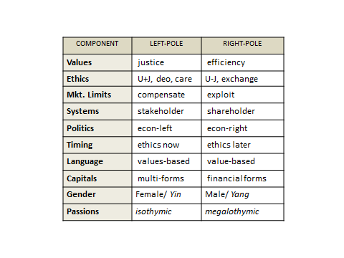

Discussion.

This case highlights some prominent contemporary issues: (i) The ethics (benefits and harms) of clarity and disclosure (to employees or troops). (ii) inequality and the disappearing (upper-) middle-class. (iii) The rise of plutocracy (or kleptocracy). (iv) How can real ‘security’ (or safety) and QOL be improved?

(i) Clarity and disclosure.

The government accounting rules for (valuing or costing) corporate pensions and the PGBC rules did not match up ($1.02 per $1, vs. 49 cents on the dollar). Good leaders should be well-aware of any situations like this and they should try to put it right, or at the very least make sure all others, the stakeholders and the public, are fully informed of the anomaly. Word-games and accounting tricks create a lot of harm in the world today. Clarity is very important. Indeed, we are working on that in this course.

The employees were not notified of the discrepancy and funding shortfall. Was that good leadership? This question of disclosure of any newly-discovered bad situation is complicated. It is a game-theoretic situation, involving several possible harms. Sometimes, it can be prudent (perhaps ethical) to keep it quiet and wait, if there is a chance that the situation will improve fairly soon. This deception avoids the collective costs of panic and loss of morale. In business, the intention to file for bankruptcy is one such situation. There was a good case-study on this involving Brainiff Airlines in the 1980’s. The CEO really had a hard time deciding whether to tell employees about impending bankruptcy.

In the military, a good general deceives the enemy (“by deception shall you do war”) but the general/leader can also sometimes be justified in withholding information from his own troops. For example, if the troops find out that a battle has been lost on a neighbouring island, they might lose the will to fight and possibly to win a battle against a clearly-unethical enemy force. Would a football league coach tell his team that another simultaneous game had just been decided and the new result meant that his team were due for league-demotion whatever the outcome of the current game? No, he should not tell them. He should not discourage them from playing or fighting “to the max.”

(ii) Inequality
In 2012 the CEO of UA was paid $13million, then $7million in 2013 following a bad merger. Meanwhile, the pilots (who one would have thought are the essence and the core of any airline) had their retirement pay reduced to $29K approx. So “500 retired pilots = 1 CEO”. Can you visualize that? Is that situation ethical, using various definitions of ethics?
The highest CEO pay to worker ratio in the World was 1731:1, in United Healthcare, 2009; at the same time a Harvard/Cambridge scientific report found that 45,000 Americans die every year (i.e. much more than a “9/11” every single month), due to the difficulties they encounter in accessing health care, especially preventative care. Is that ethical?
On the other hand, Pilot Bradlee’s expected “6 figure pension” at age 60 was arguably generous (depending who you compare it too), given a life expectancy of 20+ years. Even that higher pension would have implied about “130 retired pilots = 1 CEO”.

(iii) Plutocracy, (perhaps Kleptocracy) See the diagram: Can the situation for the working, middle and “elite” classes in the 21st century USA be mapped on this diagram?

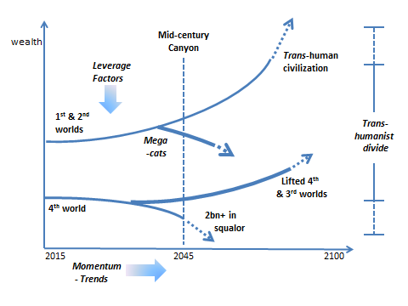

(iv) Security. In the US, there is expensive and extensive “homeland security”, corporate & private security services (for those with ability to pay), but only rather modest levels of personal security with respect to healthcare, unemployment-benefits and age-pensions. An age-pension (and medicare) provides security, safety, when one is too old to work/earn effectively. That is why it was called the 1974 ‘employee retirement income security act”. The case suggests that Federal laws, such as the pension funding and disclosure laws, tend to favor ‘the corporation’ over the ‘people’. For example, with private 401k pensions, the investment risk is borne by employee and pay inequalities are amplified. This was not so for defined benefit plans. Why is this happening? What is the trend on all these forms of security?

[end]

