Model answer for “united wins approval to dump pension plans” DW p363

Summary:

While under ‘bankruptcy protection’ in 2005 UA reached a deal with the PBGC about its employees’ pensions. The unions were reportedly not involved in the deal-making. Employees’ pensions were reduced by more than 50%. However, the “leader” CEO reportedly still had a $4.5million retirement plan that remained intact. UA was also ‘seeking to throw out’ other existing union contracts involving wages and benefits.

Discussion
This episode nicely illustrates (i) the fundamental conflict between capital and labor, or (ii) the historical contrast between benevolent vs oppressive regimes, or more simply (iii) good vs bad leaders. Remember Sun Tsu:
“the good general (or parent for that matter) retires to his tent at night only after all the troops are (cared for and asleep)”.
At a minimum, therefore, the top management that presided over the bankruptcy ‘should’ (under Sun Tsu’s prescription) be required to give up their pensions and to pay them to the PBGC, as part of a better deal for the workers; after all, under the current historical levels of inequality (within the US and globally) the top execs would probably have been paid between 30 and 300 times the average “worker” at UA, for several years.

These days, many senior execs (“leaders”) are taking home in just one year what a worker earns in 100 or more years. This situation is, as a matter of fact, damaging the economy and damaging democracy in the US. Several Nobel prize-winning fact-reporting economists have explained this carefully, including Joseph Stiglitz who is one of very few social scientists who very publically and correctly predicted the 2008 financial collapse (in a 2006 book). In my opinion, it is highly significant that the mainstream business media (CNN, Fox, CNBC, BBC, even MSNBC etc.) did not report these important Nobel-prize-quality predictions by economists and political scientists; they just made a big drama out of the ‘collapse’ afterwards. The larger history of Capitalism is full of such episodes: the system adapts and moves on, despite the injustices and harms along the way. The next phase (21st century) might well look quite like the James Martin scenarios, “the trans-human divide”, unless global political and business leaders “pull all the right levers” and adopt the global stakeholder model. Followers (the 99%) can also do this too, by “being the change” and by voting for good governments. Remember, all systems behave according to top-down and bottom up inputs (also, “middle-out” acts)

Legal ruling that a federal agency [pension benefit guaranty corp] can “take over” UA pension plans, allowing UA to ‘walk awy from nearly $10bn in unfunded liabilities”. (during that long period of under-funding, UA paid its top execs (“leaders’) quite highly, despite their leading UA through a period of losses into bankruptcy; the exec salaries could have been invested in the pension funds. For example, “the leader” CEO had a $4.5million retirement plan still intact. [he should have cut that by about 80%]).

PBGC will fund $6.6bn of the 9.8bn…Case claims PBGC is in turn “funded by payments made by companies with ‘defined benefits’ plans’. PBGC will also get $1.5bn back from UA in the form of ‘securities’ (bonds, shares) (But probably has other funding for Fed Gov.: another example of (all) taxpayers paying for corp ‘excess’ and in effect re-distributing upwards?.)) Also employees pay by having reduced pensions: 1700 down to 800pm.

Unions were not involved in the UA-PBGC talks. Yet an exec ‘said’ that the union refused to budge on demands to end their pensions’

A further bid to ‘throw out’ existing union contracts. (ultimately this is in the name of stability during a period of transition to great inequality). ‘labor challenges form: IA machinists , Air-mechanics, Assoc flight attendents. Strike threatened,

Turning to the Table, we can represent this conflict with reference to the ‘cues’ as follows

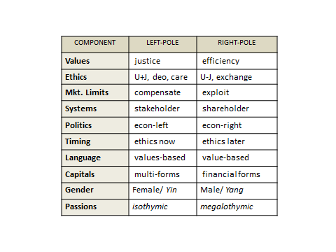
Blues: “Values”: We are all subject to ‘market forces’ and the hyper-competition in service delivery is now helping to “drive forward the industry of mankind” as Adam Smith put it. The deal with the PBGC is simply part of that larger process.
Ethics: ultimately, the approach we take brings about the greatest overall good, especially for our shareholders, customers and suppliers (including creditors). If there are any injustices (a ‘slave’ group that gets a bad deal from the decision), then it is up to voters and politicians to put that right.
KLMBS: Anyone who has studied economic theory knows that we can only stay in business by exploiting some of the KLMBS. In this case, it is the lack of DJ. We are also ‘exploiting’ (making use of ) laws that favor corporations over the (near-term) public good, but we think that this is for longer-term public benefit (timing: ethics later). The overall system in the US strongly favors financial capital formation, which can potentially benefit the public later on (although we have to admit that this depends on who owns and controls that ‘capital’ in the future and what their motives might be. Ultimately we ‘blues’ believe in the goodness and public-spiritedness of wealthy individuals, a benevolent plutocracy. For example, we expect Glenn Tilton will be donating generously in future from his $4.5m pension assets).

