Chapter 15
DYNAMICS

Alan E. Singer*

The Right trusts the market more than governments and to some extent this is regardless of their own personal wealth or whether the market has served them well, personally. Arguably, they trust ‘bottom-up’ (BU) processes like consumer purchasing decisions to deliver a reasonable balance and mixture of the human goods, whilst generally distrusting ‘top down’ processes like regulation. It might be argued on the Right that diffuse, emergent or evolution-like processes work better than intentional or deliberate ‘top-down’ (TD) plans; but especially when these are the plans of governments, kings, or presidents.

Matt Ridley is a (conservative) UK-based author and frequent contributor to the London-Times. He recently (in 2015) published a book-length defence of this idea. It is entitled The Evolution of Everything. In that book Ridley wrote that ‘bad news is man-made top-down purposed stuff, imposed on history’, that ‘good news is unplanned emergent stuff that gradually evolves’ and that ‘…things that go well are largely unintended and things that go badly are largely intended’ (p317-8). Ridley then offered many confirmatory examples.

Before mentioning a few counter-examples to Ridley’s conjecture that support a more Left-leaning view of the world with some top-down benevolent control (including a few examples that were suggested by Ridley himself, to his credit) it is perhaps worth noting that
1. Things created by top-down (TD) processes such as the actions of powerful governments or senior-layers of corporate management are not quite the same as intended things, and that
2. Things created by bottom-up (BU) processes such as unexpected discoveries or the evolution of biological organisms are not quite the same as unintended things¹.
It might also be worth noting that an earlier book by Matt Ridley entitled The Rational Optimist was reviewed by George Monbiot, an eminent UK-based Sociologist and frequent contributor to the Left-leaning Guardian (UK). Monbiot described that earlier book by Ridley as ‘telling the rich what they want to hear’ which is not at all the same as being true². One might cautiously attempt to assess the level of truthfulness of Ridley’s assertion (or conjecture) by first setting aside the above-mentioned conflation of BU vs TD with ‘intention’ and then by casually searching for some dis-confirmatory examples to place alongside Ridley’s various examples in a ‘good-bad x BU-TD’ matrix (Table 15.1) as follows:

Table 15.1. Some good and bad outcomes of deliberate and emergent processes

 |  | Moral Quality
 |  | Good | Bad
Type of Process | Deliberate (TD) | FDA, FAA, EPA | Genocides Purges
 | Emergent (BU) | Distributed innovation | Icheumonidae

For ‘emergent or BU as bad’ we need only look to what might be called the evolution-of-death. Charles Darwin himself described how the larvae of ichneumonidae sustain themselves by consuming caterpillars from the inside; just as Ridley himself noted that baby cuckoos push eggs from their non-cuckoo foster-parents’ nest, or that auto-immune disorders often arise as an unintended result of excessive hygiene (p318). As Ridley conceded, it is a bit of a stretch to argue that these things have ‘gone well’ or that they somehow contribute to the human good, even though they might be connected only remotely to the evolution of human life.

For ‘emergent or BU as good’ we have the many distributed (BU) processes of innovation and discovery by humans that have frequently led to some unforeseen benefits when placed within a market-based system. As Ridley might have emphasized, these discoveries are almost-always productive of some of the human-goods (e.g. pleasure, aesthetics, happiness, etc.). However they are also frequently bad for humans in some other respects (e.g. externalities, unsafe products, destruction of traditional lifestyles, etc.). Accordingly, many examples of market-hosted and market-tested innovation also belong in the ‘emergent or BU as bad’ category.

For ‘intended or TD as good’ (the top-left cell in Table 15.1) one might consider any of the more benevolent or uplifting policies of Left-leaning national-governments or the deliberate plans of authentic stakeholder-oriented businesses (see chapter 12). For governments, Ridley (p318) conceded only the example of the 1969 moon-landing. He might also have noted that many millions of human lives have been saved over the last 70 years or so by the creation and maintenance of regulatory agencies in the USA such as the FAA, FDA, NHTSA and the EPA (row 1 in the Table) not to mention the skillfully and quite passionately administered single-payer universal healthcare systems in many other advanced nations.

Last but obviously not least, for ‘deliberate-or-TD-as-bad’ we have the many infamous episodes, well-noted in Ridley (2015) of authoritarian projects by governments in the 20th and 21st centuries (e.g. Hitler, Stalin, Mao, Assad, etc.) including the militarization of economies, intentional purges and genocides, with many millions of human lives lost. He might also have mentioned authoritarian regimes installed and backed by the forces of capitalism, such the Pinochet regime in Chile (see chapters 21 and 26)

The evolution of death
The latter category of ‘TD as bad’ invites a more careful direct comparison with ‘BU as bad’. If one casually searches the web to find some reasonably credible sources for the numbers of people killed Worldwide since 1936 but in ways that were reasonably attributable to governments or TD state-planned actions, one quickly finds that about 90 million people were killed ‘by’ the forces of communist regimes, about 80 million were killed in World War 2 (including the Nazi & some Stalinist genocides) and about 23 million have died in ‘all wars since World War 2’ (Table 15.2.)

Table 15.2. Approximate numbers of deaths worldwide since 1936 attributable to government plans

TD GOVERNMENT PLANS | NUMBER of DEATHS
Communist regimes | 90,000,000
World War 2* | 80,000,000
All wars since WW2 | 23,000,000
TOTAL (*c.30m overlap) | 160,000,000 approx.

If one then consider the approximate numbers of deaths that seem to be broadly associated with or substantially caused by non-governmental activity: the purchase and use of the market-offerings of private enterprises (which are in turn associated with BU evolution-like processes and emergent outcomes) one finds that most of the readily-available statistics are presented on an annual basis. For example, the levels of death Worldwide for the year 2015 alone were approximately 1,200,000 for vehicle-related deaths; 300,000 for gun-related deaths (aided by Right-leaning organizations) as well as 900,000 estimated deaths from difficulties in obtaining non-state healthcare.

Table 15.3. Approximate numbers of deaths worldwide attributable to BU processes

BU or MARKET-BASED | NUMBER of DEATHS
Vehicle-related | 1,200,000pa
Gun-related | 300,000 pa
Illegal Narcotics | 250,000 pa
Other product safety | 50,000 pa
Difficulty accessing care | 1,350,000 pa
Suicide (non-gun) | 800,000 pa
TOTAL (4m x 80yrs x ½) | 160,000,000 approx.

In addition we have some 250,000 deaths per annum from black-market narcotics, roughly 50,000 from other commercial product-safety defects (a guesstimate, including pharmaceuticals) as well as about 800,000 non-gun suicides (which are BU precisely in the sense used by Ridley, although they are in a sense intentional). This is a total of almost 4 million pa. If we then make the admittedly-heroic assumption of approximately linear-growth-from-zero over the relevant 80 year period from 1936 to 2015 we arrive at a grand total of 4m x 80 years x ½ which is, wait for it: 160million. The two totals are equal. All this suggests that BU and TD dynamics are roughly equally effective as destroyers of human life, which is the transcendent human good.

Governments and Corporations
When all these examples are taken into account, it appears that the ‘TD vs. BU’ distinction or dimension relates to ‘Left vs Right’ in a quite disruptive way. This is similar to the way that negative freedom as a value-priority has to be sub-divided into freedom from state regimes vs. freedom from private regimes. The two disruptions or ambiguities can be brought together to make another telling point.

Figure 15.1. The Right-leaning evaluation of TD processes in states and corporations.
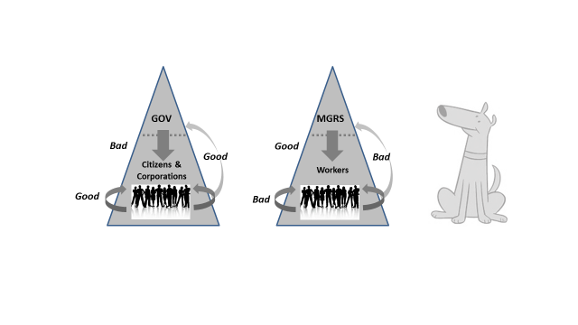
The general view from the Right is that:
1. TD regulation of corporations by governments is bad, whereas self-organizing enterprise and entrepreneurship is good; also, some BU influences by corporations and citizens are good (the left side of Figure 15.1).
2. TD control by managers of workers or employees is good, but self-organizing by groups of those workers (i.e. unions) is bad and worker representation (industrial democracy) is also bad (the right side of Figure 15.1).

The view from the Left, in point by point contrast, is that
1. TD regulation by governments of corporation and citizens is a good thing, self-organizing by citizens for Left-lobbying purposes is good, but collusion and lobbying by corporations is generally bad (as was also noted by Adam Smith in The Wealth on Nations). This is depicted in Figure 15.2 (left side)
2. The top-down control of workers by the managers of private corporations is generally bad and oppressive, whereas the self-organization of groups workers to form unions and to insist on worker–representation on corporate boards (i.e. industrial democracy) are all good things (Figure 15.2 right-side.)

Figure 15.2. The Left-leaning evaluation of TD processes in states and corporations.
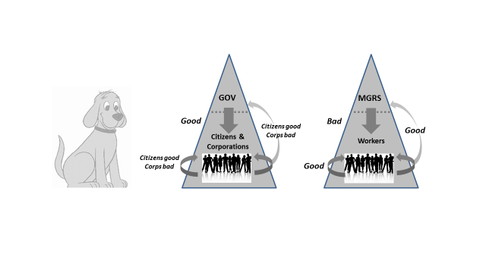

Yet again, we can see that by patiently paying attention to the descriptions and value priorities on the Left and on the Right anyone can see for themselves that these are all incomplete half-truths and malleable judgements. They can be moderated and completed simply by gazing at the other side; but one has to be willing to do that for long enough. Once again, this is not so different from paying careful attention to the geometric proof of Pythagoras theorem when one is trying to understand the equation, rather than wasting time by evaluating the teacher or shooting a messenger.

Notes
1. Some BU processes such as authentic democratic association involve the distributed intentions of many conscious minds that just happen to be located near the bottom of a hierarchy. Other BU processes are not necessarily guided by any conscious intentions although observers might very well attribute some (e.g. creationist ‘beliefs’). Also, in many collective human projects TD or BU processes seem to dominate in phases; that is, there is a BU TD BU chain or pattern over time. Many political campaigns display this pattern.

2. This is not the same as being true, although there are some complicated Continental-European philosophical arguments to the contrary.

