PREFACE

Alan E. Singer*

Whilst writing this book I received an unexpected invitation to University Diego Portales in Santiago, Chile. In nearby Valparaiso I ventured into one of the hillside cemeteries that are filled with Spanish and English tombstones. I sat down to rest and when I looked up I saw directly ahead an inscription ‘in memory of the officers and seamen slain on board the US Frigate Essex’.

Figure 1. The Memorial for the USS Essex

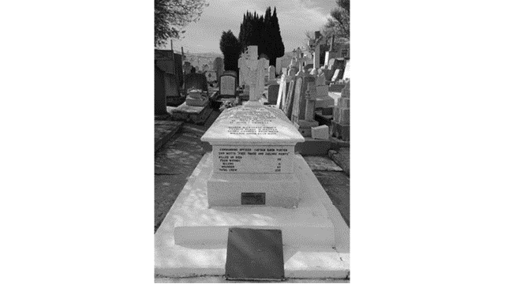

Since my family reside in the English county of Essex I looked more closely. What happened next seems more than a coincidence: the tombstone proclaimed that ‘the officers and seamen slain on board the US Frigate Essex in this harbor (were) in an engagement with Her British Majesty’s frigate Phoebe and Brig Cherub, on March 28th 1814’. Then, on the front of the tomb it was inscribed that the commanding officer of the Essex, one Captain David Porter, had declared the ship’s motto to be:
‘Free Trade and Sailor’s Rights’
That very idea of free trade on the Economic-Right and sailors’ rights’ on the political-Left is quite representative of this entire book about understanding Left and Right. As Paul Gilje put it in his 2013 book on the 1812 war:
‘Any banner with the words ‘free trade’… rallied those from the top as well as those on the bottom of society (who)…understood that trade unfettered by restrictions meant jobs and higher wages (whilst) ‘sailors rights’ asserted a broad definition of citizenship that spread its guardian wings aboard ships and within nations’ (Gilje 2013)
Figure 2. Free Trade and Sailors’ Rights

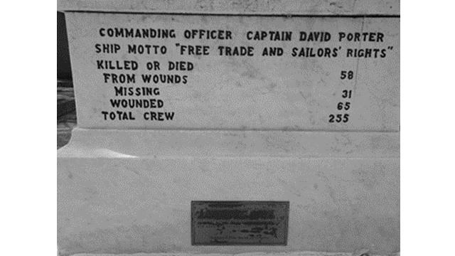

It is of course always possible to advocate Capitalism without workers’ rights; but this is partial and incomplete with respect to the various forms of the good. It would be quite like recommending a mathematics program that has only geometry and algebra courses, but no calculus. Significantly, quite a few students would like that program although it would be bad for them.
This brings us to a second coincidence surrounding the actual writing of the book. Some four months after visiting Valparaiso I was staying at my partner’s house overlooking the Philippine Sea. When I had just finished a near-final edit of this book I sat down on the balcony and stared back towards the ‘East’ and far-away Chile. I looked up again and this time, in dead-center view about half a mile away was a huge cargo vessel moving slowly to my left carrying three massive pyramids of material (maybe cement) on its open deck. Three Pyramids! The ones at Giza (in Egypt) are thought to be sized in accordance with Pythagoras theorem about the sides of right-angled triangles, which is frequently mentioned in this book because of the way that anyone can see for themselves that the theorem is correct (see chapter 3 on ‘understandings’). Most significantly, ancient Egyptian mythology has it that right-angled triangles are intimately associated with the deities, a whole elaborate world of the imagination that, unlike mathematics, many people do like to read and talk about. Such myths are not unlike the political conspiracy theories (stories) that become fashionable and influential from time to time.

Figure 3. The three pyramids at Giza

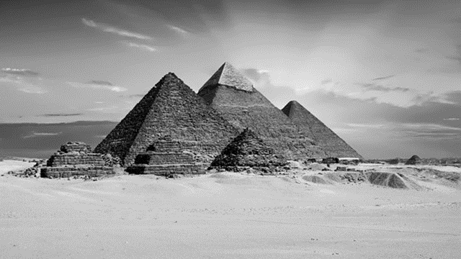
By TheDigitalArtist on www.Pixabay.com free images
The central argument of this book is that we currently need a politics based on what is actually known about an assumed-to-exist external reality: known, that is, after gazing at it for a long time from both sides. The message is similar to that of the song ‘Both Sides Now’ by Joni Mitchell, except that one really can get to know life on the Left and the Right very well. Policies should be based on facts that everyone can see for themselves if only they look and pay attention for long enough. One might build a house without in effect following Pythagoras’ theorem, but it will collapse under stress. At that point, one might embark upon a more careful search for the relevant truth, but it might be too late. Similar things have been said before about 21st century politics and economics: Cambridge University Professor Peter Nolan noted (in a 2008 book) that ‘the owl of Minerva spreads its wings only after the darkness has fallen’, a warning that was echoed in 2011 by an eminent sociologist Ulrich Beck who wrote ‘When a world-order breaks down, that is when people begin to think about it’ (Beck 2011). Perhaps it is now time to think about what follows.

References
Beck U (2011) Kooperien oder schietern die existenzkriseder europaischen union. [Cooperate or else threaten the existence of the European Union]. Blatter fur Deutch und International Politik 2 (2011) pp41-53. (cited in the preface of H. Geiselberger (ed.) The Great Regression. Cambridge: Polity Press.
Gilje P (2013) Free Trade and Sailors’ Rights in the War of 1812. Cambridge, Cambridge University Press.
Nolan P (2008) Capitalism and Freedom: the Contradictory Character of Globalization Anthem Press.
Singer A (in press) Understanding Left and Right: an Illustrated Guide to the Political Divide. NY: Nova

