Chapter X
TAXES:
LOOKING HIGH & LOW

People often say things like ‘I’m a Conservative so I like low-taxes’ or ‘I’m a Liberal, so I support progressive taxation’. The truth is, however, that it does not matter at all who the person is. What does matter is the possibility of achieving a Pythagoras-theorem-like understanding of the conditions that promote human flourishing. Anyone can achieve this understanding by studying carefully for long enough.

STATEMENTS
That quest will lead to many statements about ‘conditions for flourishing’ that are subject to caveats or further conditions. For example, ex-president Obama recently said that ‘democracy and co-operation…could only work (in future) if the rich paid more in tax.’ In assessing the truth of that statement, one might consider, amongst other things, that successful corporations in Japan used to maintain a pay-ratio of about 30:1 between their highest paid officers and lowest-paid employees. It seemed healthy at the time and it still does; something like having one teacher for every 30 children. In the USA today, one finds pay ratios higher than 3000:1. In 2017, for example, the McDonalds CEO received ‘$21.8 million, which is 3,101 times more than the typical McDonald’s employee’ (Pizzigati 2018). Everyone, including that CEO, can see that this ratio at least presents a challenge to democracy, co-operation and human flourishing. It is also easily explains why ‘the top 10-20% pay most of the tax’¹.

More generally, since about 1980 there has been a substantial increase in economic inequality. When conservative Right-dog hears this, he often growls that inequality does not matter, unless perhaps the poor are getting poorer. He might add, truthfully, that a dislike of inequality is often due to envy, which is a bad thing. In any case, there has also been strong economic growth since 1980 whereupon a rising tide lifts all boats and wealth trickles down. Left dog immediately barks back that:
1. Many people are getting poorer and wealth does not trickle down,
2. Since1980 wealth has mostly gushed up to the top 1%.
3. If anything, it is poverty and homelessness that ‘trickles down’.
Rising house prices in some cities illustrate the latter. They have squeezed out first-time-buyer dual-income households, who continue to rent rather than buy, which in turn squeezes out traditional single renters, some of whom end up homeless.

Our two growling dogs can easily understand and partly-agree with all of the above. Both also know that the last few decades has seen the emergence if many winner-take-most markets (WTMMs). Professional sports such as tennis are the standard example. Everyone knows that Roger Federer has talent. Some might also know that he has accumulated about $400,000,000 from brand endorsements and the creation of other TV images for the global TV-WTMM. In effect, Roger has been paid $200 (after-tax) for every stroke he ever played in his official matches, including all the bad shots. Meanwhile, many not-quite-so-good players received little or nothing. Roger flourishes, many are entertained, but once again, everyone can see that something is not quite right.

Suppose a progressive high-top-end income tax had reduced Roger’s take-home pay to just $20 per stroke. His accrued personal wealth would then be $40,000,000. Would he have played any differently? Left-dog and Right dog generally agree that he would have played the same game. After all, payment of around $170,000 per month is enough to motivate anyone. Left dog might also point out, again truthfully, that:
1. People have complicated motives for being productive, including aesthetics (or flow) and community or public benefits.
2. Psychologists often refer to an ‘inverted-U curve’ whereby the best human performance is often achieved when the $-incentive or ‘extrinsic motivation’ is moderate, not extreme.
3. When so many people have nothing, accepting more than one or two million dollars per annum seems very greedy. It might even reduce the rich person’s happiness, as in the ancient story of King Midas.

Right-dog does not like any of these true statements. He might bark ‘spare me the psycho-babble’, perhaps adding that ‘all people are entitled to the fruits of their labor’ (see Chapter 1). While warming to that theme, he might wish ‘good luck’ to people like Jeff Bezos, the CEO of Amazon whose net worth in 2018 stood at around $140,000,000,000 and who reportedly makes more money in one minute than the median-paid Amazon employee makes in a year. Left dog barks back quite loudly that many high-income people such as Roger, Jeff and Bill (Gates) have actually appropriated the fruits of others’ labor (while many others do not ‘labor’ at all because their income is ‘unearned’). Tennis players like Roger co-produce TV images in partnership with a global telecommunications industry. Without his willing band of co-producers, he would be much less wealthy, more like the high-performing Olympic athletes in the movie Chariots of Fire. Most hard working ‘band’ members, however, received less than 1/1000 of his pay. This bothers Left dog, but Right dog really does not care. His view of the moral high ground is to grab a tennis racket and start practicing. He also growls that things like technology, talent and the luck are all elements of an evolutionary process that necessarily creates winners, losers, life and death.

Table 1. Summary of reasons for high and low income tax rates
LEFT LIKES HIGH BECAUSE… | RIGHT LIKES LOW BECAUSE…
30:1 pay ratios seem reasonable | Pay ratios should be set by the market
Inequality is too high & increasing | Inequality does not matter. Envy is bad.
Wealth gushes up, poverty trickles down | Wealth trickles down
WTMMs distorted the ratio, ‘Federer effect’ | Technology, talent, evolution creates losers
Complex motives, Inverted–U, greed | Psycho-babble, be free to acquire $ billions
Others’ labor, unearned, exploitation, luck | Appropriate fruits of one’s labor.
Classroom rewards for performance | No classroom, only supply!
Some pie is tax-funded, strategies shrink pie | No fixed pie, maximize incentives to produce
Rigged or unearned high incomes, lotteries | The market is fair and sets top pay
Many poor people have several jobs | Many poor people are lazy
Close loopholes using NSA-tech | Rich will find loopholes
Few productive rich emigrate | Productive rich might emigrate
Increase tax to increase revenue (Laffer) | Reduce tax to increase revenue (Laffer)
More $ for needy citizens & public goods | More $ for me & my family
$-to-poor lifts spending, creates growth | $-to-rich lifts production, lowers inflation
Government programs effective, reduce poverty | Charity is effective, low taxes reduce poverty
‘The rich want out’ | ‘Noblesse Oblige’
‘No taxation without representation’ | Flat-tax gives everyone ‘skin in the game’

Right-dog sometimes tries another tack: he barks out clearly and truthfully that there is ‘no fixed pie’ to be shared out. He might also growl that whenever people like Roger, Jeff or Bill enlarge that pie, they deserve to keep all the extra slices. Like some 19th century pioneer clearing new territory, these enterprising men do not have an obligation to share any ‘fruits’. In addition, to make the pie grow as large as possible there must be no limits on the financial incentives. Therefore, for humans to flourish, says Right-dog, people like Roger, Bill and Jeff must be left alone and free from government interference. Left-dog and many other people cannot see this at all and might invite Right-dog to take another look.

Returning briefly to that comfortable old-style 30:1 corporation, our two friendly dogs might also consider the question of a fair or proper distribution of sweets in a high school classroom as ‘pay for performance’ on a math test (perhaps a test on Pythagoras theorem). Many teachers say it should be something like ‘3 for the top scorer, 2 for the runner-up and 1 for everyone else’. In other words a 3:1 ratio rather than 30:1 or 3000:1. Right-dog simply growls that the adult world is not like a classroom. One must consider ‘who produced those sweets and why?’ Left-dog growls again about co-production, perhaps adding that:
1. Extra pie or sweets for adult winners often involve anti-competitive (monopolistic) practices that shrink the whole pie,
2. Pay-consultants and board members often collude, or ‘rig’ the system, and
3. Government contracts funded by taxation are a major source of revenue for many private-corporations
As an example of that third point, he might note that Lockheed Martin Corporation in the US reportedly ‘took in $35.2bn from taxpayers in 2017’ while their CEO ‘pocketed $22,866,843 or about 800 times the average for US workers²’ (Pizzigati 2018).

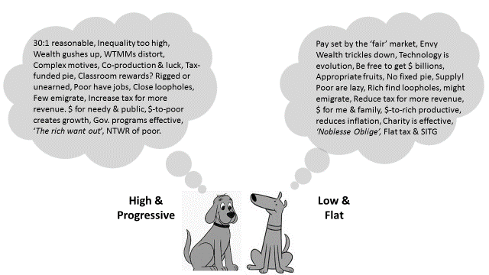

Figure 1. Two dogs discussing income taxes

Left-dog has not yet finished. Much of the taxable income of wealthy individuals is unearned: property-rentals, interest, dividends and capital gains. Unlike Roger who at least sweats it out on the tennis courts, many wealthy people do no work. Right-dog might growl back that many of those rent - yielding assets were rewards for sweat in times-gone-by, whereupon Left dog growls about the lottery of stock prices and real estate gains, or the so-called ‘ovarian-lottery’ of massive private inheritance. Right dog, now getting quite agitated, barks back that many poor people are lazy, that high tax rates simply encourage the rich to find tax-avoidance loopholes or to emigrate to tax havens, taking their money with them. Left dog in turn growls that many poor people work actually very hard in several jobs, that governments should deploy NSA type technology to close those tax loopholes, whilst emigration for tax reasons is not so common.
CURVES
That Pythagoras-like ‘no fixed pie’ statement from Right-dog sometimes prompts calm consideration of three more true statements about income tax:
1. A tax rate of 0% would generate zero revenue to a government (in any country with a market-based economic system).
2. A 100% rate would also generate zero because no one would work; or perhaps a small amount from paid work done for communal or altruistic reasons. (A totalitarian government, in contrast, can sell products of citizens’ forced labor.)
3. Therefore, there must be a regime of tax rates somewhere in between 0% and 100% that maximizes revenues (in a market economy).
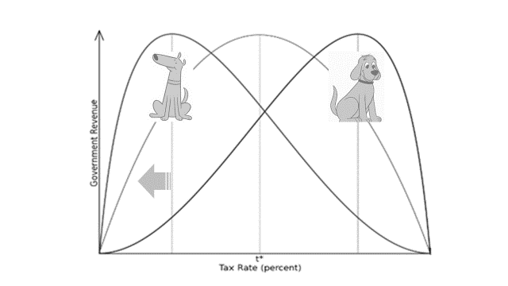
[source: adapted from commons. Wikimedia]

Figure 2. Laffer curves based on Right and Left preferences
Taken together, these three truths do not imply that that tax increases generate more tax-revenue; nor that that tax reductions lead to more revenue due to more ‘pie’. The accuracy of those statements depends on the initial tax rates, but also on the conceptualized shape of the curve in Figure 2.
Left dog likes the idea that the curve peaks at a high rate (i.e. towards the right of the curve). He can find several studies that ‘indicate, suggest, or show’ that high taxation linked to downward redistribution creates economic growth from things like infrastructure spending and the fact that poor people quickly spend any extra dollars. Right dog immediately starts to growl about inflationary pressures. He prefers the idea that the peak of the Laffer curve (Figure 2) is at a low rate. He has collected some studies that ‘show’ that low personal income taxes encourage productive business investment in the home country. Anyone who persists with the research, however, will find that the bulk of the more credible studies (e.g. the CBO in the US) support the Left side of this particular dog-fight. In all fairness to Right-dog, one has to consider that he might be playing a bit of a deceptive trick here (indicated by the grey arrow in Figure 2), perhaps even deceiving himself, because he has several other reasons for liking tax reductions. They:
1. Give him or his family more money immediately,
2. Tend to reduce the size of government (because of the lower revenues that he secretly expects) and
3. Make the rich richer; which he likes because he is already rich or imagines that he will be one day.
As a result, Right-dog frequently growls that the optimal revenue-raising tax-rate is low, probably around 10-30%.

EFFECTIVENESS
Regardless of tax rates, our two dogs also disagree about the relative merits of tax-funded social programs in comparison with private charity (see the chapter on Trust). Right dog growls that low taxation and philanthropy obviously reduce poverty and promote human flourishing. Left dog barks back that tax-funded government programs are more effective and efficient, less corrupt and certainly far less selective than most private programs. In the US, for example, Social Security Medicaid and Medicare help the poor far more widely and on a larger scale than private charitable foundations. One reason is their massive level of funding: compulsory taxation raises far more than voluntary donations: many people do not donate at all because they know that others don’t. To use the language of Game theory (chapter 13) donors ‘defect’. On top of that, these days, many of ‘the rich want out’: to retreat behind their castle walls or into other private spaces, without maintaining much sense of Noblesse Oblige. The late Alvin Toffler, the insightful author of Future Shock, noticed that this trend was well under way as early as 1990 and it is currently gaining momentum.

Many conservatives heartily agree with Left dog that wealthy individuals do indeed have an obligation to help others (i.e. Noblesse Oblige) but they prefer to leave it as a matter of private conscience rather than public policy. This preference is implicit in yet another significant line of thinking about income tax. The political Right sometimes argue for a low ‘flat tax’ with reference to the principle of ‘skin in the game’ (SITG). This means that anyone with a personal financial stake (the ‘skin’) in a project has an incentive to eliminate reckless risk-taking within that project. Accordingly, says Right-dog, if everyone paid the same rate of tax, it would help to discourage ‘reckless’ government. A flat tax would also be similar to a traditional Church Tithe (still common in the US) whereby congregants pay around 10% of their income to a church and the church-based community stays strong. Left dog gets agitated now: a low flat tax obviously worsens poverty, because under progressive tax regimes many of the poor pay ‘negative’ tax or receive credits. Flat tax also means ‘low at the top’ so it would enrich and empower the already wealthy. In fact, growls Left-dog, these metaphors of ‘skin’ and ‘tithe’ would only apply under a functioning one-person-one-vote system of direct control of government projects. The important thing, says Left-dog, is to ‘get money out of politics’ and to persist with the struggle for ‘no taxation without representation’ (NTWR).

NUMBERS
When the tired dogs settle down and contemplate mainly their own arguments, they generally develop a liking for tax regimes similar to the ones shown in Figures 3 and 4. Left dog wants around 85 -100% tax on incomes above about $3,000,000 p.a. (with ‘100%’ amounting to a maximum wage). Some people on the Left would prefer that ‘maximum’ to be much lower, about $500,000 p.a. and ask whether anyone needs or deserves more than that. Down the scale, Left dog wants around 50% tax on income in the $250,000 to $500,000 range and no tax (perhaps some credit) on incomes below about $20,000. Right dog prefers everything low and simple: 10% to 30% on all income, maybe 10-20% at the low end.

Under Left-dog’s 90% top-rate a CEO on $10 million p.a. would pay about $8.2 million in tax ($195K on the first 500K, then 300K, 1400K & 6300K) and bank around $150,000 per month. If that CEO stayed in the job for 8 years, he could quite easily save around $14 million: enough to keep most people interested. With the 100%, top rate (Figure 3) our CEO would take home $92,000 every month. His gross pay would probably then reduce to $3million, possibly freeing up some corporate funds for other purposes.
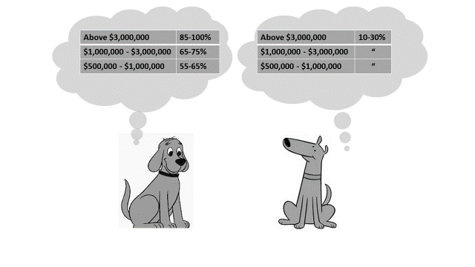
Figure 3. Preferred income tax rates at the high-end

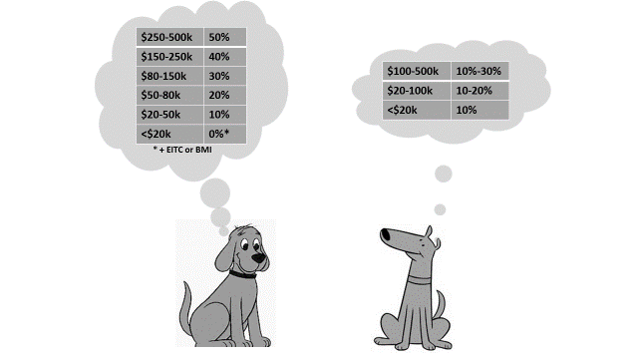

Figure 4. Preferred rates at the low-end

Table 2. Golden-mean tax rates1

INCOME BRACKET | MID-RANGE % | MID POINT %
>3mill | 47.5 – 65* | 56
1-3mill | 38-53 | 45
500K-1mill | 32-47 | 40
250-500K | 30-40 | 35
150-250K | 25-35 | 30

* i.e. (100+30)/2
Left-dog also likes to mention the lucky CEO of United Health whose remuneration package in 2007 was around $107,000,000. Under a 90% top-rate, he would have kept only $1million per month. In fact, both CEOs did much better under the actual 2007 tax-regime: our ‘10 million dollar man’ could bank around $650,000 per month, whilst the United CEO could deposit $6.5million per month (i.e. a cool $78 million for that one year).

So, all things considered, which income tax regime is really most likely to promote human flourishing? Everyone can eventually see for themselves that every statement in Table 1 and Figure 1 (above) is partly, substantially or entirely true. This is like ‘seeing’ Pythagoras’ theorem, which also has caveats and conditions. It is now almost obvious that we should split the difference (Table 2). In doing this, we would simply be applying Aristotle’s time-honored principle of The Golden Mean in human affairs. That principle has endured even longer than Pythagoras’ theorem and it is equally dependable as a guide to practice. The result is that our United Health CEO faces a tax rate of around 56% and banks $4 million per month. Left dog feels this rate is much too low, but he also accepts that life is not fair.

CAPITAL GAINS TAX
Some of those lucky CEOs’ remuneration came from the sale of shares. One therefore has to consider the proper way to tax personal capital gains, such as shares sold by executives. Left dog wants those taxes to be high (say 30-50%) because they:
1. Tax capital, not labor (i.e. employees or workers), and
2. Are automatically progressive, because the wealthy pay much more: one report has it that the wealthiest 1/10th of 1% ‘report about half of all capital gains’.
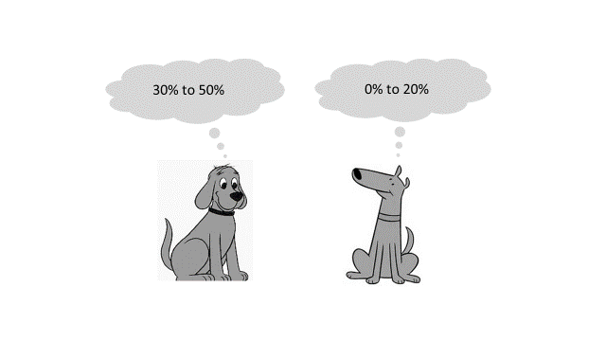
Figure 5. Preferred capital gains tax rates.
For these very same reasons Right-dog dislikes capital gains taxes (CGT) and wants the lowest possible rates (0-20%). In truth, most people who have enjoyed a capital gain dislike CGT too. Suppose that you (or grandad) had been in a position to purchase a brand new E-type Jaguar Lightweight Competition model in 1963 for around $7500. For 54 years, you demonstrated impressive self-discipline by keeping it off-road in a clean dry garage. Then, in 2017, you made a capital gain of $7.3 million: enough to live in luxury without ever working again; for, according to Wikipedia:
…a 1963 E-type Jaguar in near original condition … sold in 2017 for $7,370,000 at auction in Scottsdale, Arizona.
Should anyone be required to pay tax on that? If so, how much? Left dog growls that ‘it’s obviously ridiculous to tax hard-earned wages but not to tax such a huge personal windfall’. He also notes, to the disgust of Right-dog, that revenue from CGT can fund public transport and bike lanes. Maybe we should treat the whole gain on the Jag as taxable income in 2017. The two dogs might be able to agree that taxing $4.3 million of the gain at 90% or 100% seems excessive. Perhaps we should allocate the gain over the entire 54 years, call it $137,000 p.a. and then apply an income tax rate of around 30% so you would pay around $2.2 million. Since this approach might prove difficult to enforce, it might be better to simply tax realized capital gains at a flat rate around 30-50% (Figure 6). You sell the Jag, pay around $2.2 - 3.5 million and keep $3.8 - 5 million. You realize that your tax payment helps meet other people’s needs, so you feel very good.
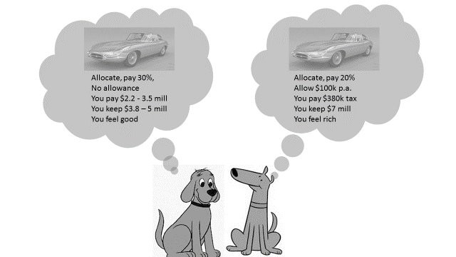
Figure 6. Preferred capital-gains-tax regimes

Right dog is not feeling good: if we are going to have capital gains tax we should at least allow about $100,000 p.a. tax-free. That works out at $5.4 million of allowance over 54 years. You now only pay about 20% on $1.9 million, which is $380,000. If we have a flat rate CGT make it 10% so you pay 730,000. Either way you get to keep around $6-7 million and you will feel even better, perhaps you and your family flourish even more.

CORPORATION TAX
The politics of capital gains tax (CGT) and corporation tax (CT) are quite similar. CT includes elements of CGT because corporations pay tax on profits from capital gains, namely:
1. Assets sold for more than the value previously recorded in the accounts (i.e. ‘realized gains’) or
2. Accounting or ‘book’ profits from assets that are upwardly-re-valued but not sold.
In addition, both taxes are progressive because they affect wealthy people more (the top 1% owns about 40% of all shares). Left dog accordingly likes a high CT rate (30-50%) and emphasizes all the arguments for it. Right-dog likes low CT (0-20%) and duly states the counter-points (Figure 7).
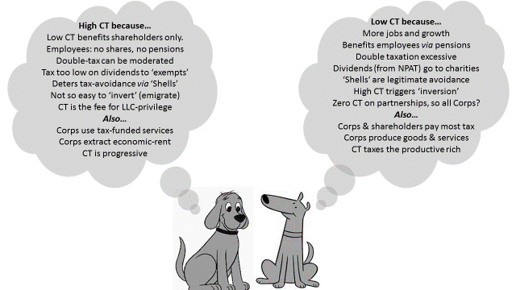

Figure 7. Two Dogs on Corporation Taxes
This particular dogfight often starts with the Right insisting that ‘double taxation is unfair and excessive’. The ‘double’ refers to:
1. The CT paid by the corporation on its profits that in a sense belong to shareholders and secondly
2. Income tax paid by shareholders on any dividends that they receive.
Right dog might quickly add that many corporate dividends are received by charities that do good work. Left dog responds that there are many ways to compensate for double-taxation, whilst ‘dividends to charities’ are often shameless tax avoidance schemes. If CT is zero and the dividends are all paid to tax-exempt entities, then no tax at all is collected.
Right dog, who likes zero or low CT (and small government) growls back that low CT attracts MNC direct investment, creates jobs and promotes economic growth. It also benefits employees who have a stake in private pension funds. Left dog then barks that low CT overwhelmingly benefits already-wealthy shareholders and executives. Most employees do not own shares and many have no pensions. In any case, reductions in CT often trigger share-buybacks by corporations, lifting the value of shares held by executives, without adding to direct capital investment and jobs.
Left dog might then add that high CT would help to deter tax avoidance schemes involving shell corporations that do not directly produce anything. Right dog responds that shells are just another legitimate avoidance method and that high CT often triggers corporate ‘inversions’ (like emigration). Left dog growls again about the need for international co-operation to close all those loopholes, adding that corporations should be taxed because they:
1. Use tax-funded public services (e.g. roads, water supplies),
2. Extract ‘rents’ often making profits from property, rather than innovation and production.
3. Should pay a fee for their special privilege of limited liability (see the chapter on ‘Persons’) and the possibility of government bailouts.
Like the reader, Right dog is now getting tired. He barks one more time that it is those so-called wealthier shareholders who pay most of the taxes anyway, that those ‘privileged’ LLC corporations actually produce most of the pie and that all businesses should be treated equally (some business-entities such as partnerships are exempt from CT in some jurisdictions). With his remaining energy, Left dog barks back his favorite true statement: CT is progressive: it helps to reduce inequality amongst people and accordingly promotes human flourishing³. Right dog might finally be provoked into throwing a wild Right-hook: that ‘all taxes are unjustified appropriations of private property’ which is obviously false. (Result: Top income tax rate = 56%, CGT=CT=25%).
Reference
Sam Pizzigati (2018) Minimum wage? It's time to talk about a maximum wage. The Guardian, 30 Jun.

Notes
1. According to publically available US Inland Revenue service (IRS) tables, the 400 highest-income individuals in the US reported an adjusted net income before tax of about $1,000,000 per day, so it’s no surprise that they pay a significant amount of tax even when their average tax rate is quite low. Let’s now suppose that any such income above, say, $10 million per annum were taxed in at a (1950’s style) top marginal rate of 90% (instead of the typical relevant current rate of around 20%). The extra revenue to the government would cover about 40% of all public college costs in the USA (i.e. everyone’s tuition, fees and accommodation). This amount of potential extra revenue is from only these 400 highest-income taxpayers. To make it real, they would have to agree to manage on just $100,000 per day whilst doing whatever they do, but also agree (or be required) to remain as a US tax resident. In the USA there are about 140,000,000 individual taxpayers, so the ‘top 0.1%’ contains roughly an additional 140,000 high-income individuals. The potential for deficit reduction and public-goods delivery is thus apparent.
2. For some other examples see…Robert Reich (2019) “Trump offers socialism for the rich, capitalism for everyone else” The Guardian Mon 11 Feb 2019.
3. The tax rates preferred by the two sides also depend on their assumptions about how the government will spend those tax revenues (Figure 8).
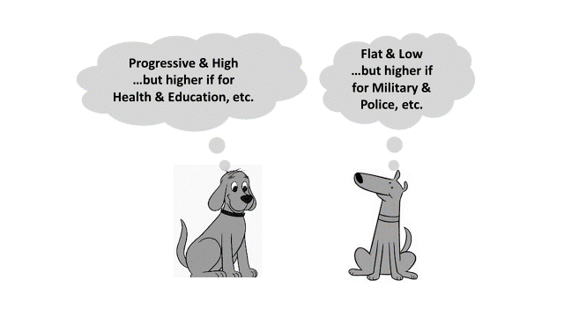
Figure 8. Preferred tax regimes depend on expenditure categories

(i) If the money is to be spent on the Military, Security, Police & Prisons (i.e. ‘The Dark side”) then the Right might agree to somewhat higher tax rates (under the assumption that spending on those things would increase). The Left would prefer lower rates in this situation in order to reduce this spending.
(ii) If the money were to be spent on Healthcare, Education, Arts, Social Services and Public Spaces then the Left would generally prefer even higher tax rates, in order to increase spending on these things, whereas the Right would prefer even lower tax rates.

