A new species of kukri Snake (Oligodon Fitzinger, 1826; Squamata: Colubridae) from the Cat Tien National Park, southern Vietnam

ANNA B. VASSILIEVA^{1,2*}, EDUARD A. GALOYAN^{2,3}, NIKOLAY A. POYARKOV Jr^{1,2}., ROBERT WAYNE VAN DEVENDER⁴, WOLFGANG BÖHME⁴, PETER GEISSLER^{5*},

¹ Department of Vertebrate Zoology, Biological Faculty, Lomonosov Moscow State University, Leninskiye Gory, GSP–1, Moscow 119991, Russia
²Joint Russian-Vietnamese Tropical Research and Technological Center of the A.N. Severtsov Institute of Ecology and Evolution, South Branch, 3, Street 3/2, 10 District, Ho Chi Minh City, Vietnam
³Zoological Museum, Lomonosov Moscow State University, Bolshaya Nikitskaya st. 6., Moscow 125009, Russia
⁴Department of Biology, Appalachian State University, Boone, NC 28608, USA;
⁵Zoologisches Forschungsmuseum Alexander Koenig, Adenauerallee 160, 53113 Bonn, Germany; E-Mail: pgeissler84@yahoo.de
*corresponding authors: vassil.anna@gmail.com, pgeissler84@yahoo.de
Abstract
Key words:
Introduction
Being one of the most speciose snake genera in South and Southeast Asia, Oligodon Fitzinger, 1826 currently comprises 74 described, valid taxa (Green 2010, Green et al. 2010, David & Vogel 2012, David et al. 2011, 2012, Neang et al. 2012). Beside the distinctly enlarged rostral scale, the most prominent and eponymous character are the enlarged, broad and recurved kukri-shaped hind teeth. They are interpreted as an evolutionary adaptation to oophagy (Coleman et al. 1993). Interestingly, and in difference to other oophagus snakes, the kukri teeth allow these snakes to feed on eggs too large to swallow, by sawing a hole into the egg-shell (Minton & Anderson 1963). Indochina, comprising Cambodia, Laos and Vietnam, currently houses 21 known species (see table 1), and therefore forms a center of species richness for this genus (David et al. 2012). The taxonomy and systematics of Oligodon is under discussion for about 70 years, since Smith (1943) made the first attempt to characterize species groups reflecting phylogenetic units. Based on hemipenial traits he disposed seven species groups, of which four are known to be present in Indochina (according to Smith 1943, David et al. 2008 a & b, David et al. 2012, Neang et al. 2012,): Oligodon cinereus – group (O. cinereus, O. albocinctus, O. inornatus, O. joynsoni, and O. nagao); Oligodon cyclurus – group (O. formosanus, O. ocellatus, O. fasciolatus, O. kampucheaensis, O. saintgironsi and O. macrurus); Oligodon taeniatus – group (O. deuvei, O. moricei, O. taeniatus, O. mouhoti and O. barroni); Oligodon dorsalis - group (O. lacroixi, O. eberhardti and O. catenatus). Later on, these surrected species groups were mainly supported by modern phylogenetic approaches (Green et al. 2010). Currently only one species, Oligodon annamensis Leviton, 1953 is not clearly assignable to one of the mentioned groups, but was proposed by Leviton (1953, 1960) to be part of the “taeniatus-cyclurus-complex”. We follow the recommendations of Kaiser et al. (2013) and consider the different names of subgroups of the genus Oligodon Fitzinger, 1826 proposed by Raymond T. Hoser as unscientific and invalid. During herpetological surveys in Cat Tien National Park in 2009, one reddish juvenile specimen was caught and preliminarily determined as O. cinereus, based on its body scale counts (Geissler et al. 2011). In the subsequent years several other differently colored specimens were found, which however showed similar squamation features. A second close examination of all specimens and the comparison of their morphological traits with those of all other Oligodon species revealed that they differ significantly from all described taxa. As a consequence we herein assign them to a new species, which is described below.
Material and methods
Visual herpetological surveys were undertaken during periods from December 2010 to January 2011, from July 2011 to July 2012, and from December 2012 to January 2013 (Anna and Ed)…….in semi-deciduous forests in the Nam Cat Tien part of Cat Tien National Park. Specimens were photographed after capture and subsequently fixed and stored in 70% ethanol. For determination, morphological characters and morphometric ratios were used, which are regarded as of taxonomic importance within the genus Oligodon (see Smith 1943, Wagner 1975, David et al. 2008 a & b, David & Vogel 2012, David et al. 2012). Scale counts and measurements were taken under an Olympus SZ30 and Leica EZ4 microscopes using ? a digital caliper. Scale counts were made according to Dowling (1951). Maxillary teeth were counted by slightly pushing back the soft tissue with a preparation pin. The hemipenes in one preserved adult male were extracted from their sheaths, the left one was dissected and turned inside out (inverted) for morphological analysis. The following measurements and counts were taken: head length (HL, from snout tip to jaw angles); head width (HW); head height (HH); interorbital distance (IO); eye-nostril distance (EN, from anterior edge of orbit to posterior edge of nostril; internarial distance (IN); eye diameter (ED, horizontal); snout length (SnL, from the tip of rostral to the anerior margin of eye); snout vent length (SVL); tail length (TaL); ratio tail length / total length (TaL/TL); total length (TL); number of dorsal scale rows at neck (ASR, about one HL behind head); dorsal scale rows (DSR); supralabial scales (SL); infralabial scales (IL); loreal scale (LOR); number of dorsal scales at midbody (MSR, at number of VEN/2); preocular scales (PreOC); postocular scales (PosOc); number of dorsal scale rows before vent (PSR); subcaudal scales (SC); ventral scales (VEN). Symmetric characters are given in left / right order. Numbers of pattern-units (like crossbars or vertebral blotches) are provided as number on body + numbers on tail. Types and referring material are stored in the herpetological collections of the Institute for Ecology and Biological Research (IEBR) in Hanoi, Vietnam, the Zoological Research Museum Alexander Koenig (ZFMK) in Bonn, Germany, and the Zoological Museum of Moscow State University (ZMMU) in Moscow, Russia.

Species description
Oligodon lineomaculatus sp. nov.
Oligodon cinereus, Geissler, Nguyen, Poyarkov, Böhme, 2011

Holotype. ZMMU R-13865 (field ID ZMMU NAP-02281), adult male from the environs of Ben Cu forest station, Nam Cat Tien sector, Cat Tien National Park, Dong Nai Province, southern Vietnam (11°26' 03" N, 107° 25' 42" E, 130 m a.s.l.), collected by Anna B. Vassilieva on 20 January 2011.
Paratypes. ZMMU R-13815, (field ID ZMMU NAP-02165), adult male (roadkill) from type locality: Nam Cat Tien sector, Cat Tien National Park, Dong Nai Province, southern Vietnam (11°25' 43" N, 107° 25' 38" E, 148 m a.s.l.) collected on 13 March 2012 by Eduard A. Galoyan; ZMMU R-13815 (field ID ZMMU NAP-02189), subadult female from type locality (11°27' 03" N, 107° 21' 52" E, 167 m a.s.l.) collected on 04 April 2012 by Eduard A. Galoyan; ZMMU R-13866 (field ID ZMMU NAP-02240), adult male from type locality (11°26' 23" N, 107°25' 33" E; 143 m a.s.l.), collected on 17 December 2012 by Anna B. Vassilieva; ZMMU R-11473, juvenile of undetermined gender from type locality, collected on 16 March 2003 by Vladimir V. Bobrov (preliminarily identified as Oligodon sp.); ZFMK 88921, juvenile of unknown gender, from type locality (11°25' 43" N, 107° 25' 38" E, 148 m a.s.l.) collected by Robert Wayne Van Devender on 02 June 2009.
Diagnosis. A medium-sized Oligodon species, a member of the O. cyclurus group (fide Smith 1943, David et al 2008b, Green et al. 2010) on the basis of the following morphological attributes: (1) deeply forked hemipenes without spines, (2) 17-17-15 dorsal scale rows, (3) 8-10 maxillary teeth, the posterior three being enlarged, (4) a complete head scalation complement, including a loreal but no presubocular, (5) an entire anal plate; and (6) a spotted and striped dorsal pattern. Oligodon lineomaculatus sp. nov. differs from all other members of the O. cyclurus group by the combination of the following morphological characters: (7) nasal entire; (8) 2 small postoculars, almost equal in size; (9) 167-178 ventrals; (10) 31-35 subcaudals; (11) tail relatively short (TaL/TL = 0.11-0.13); (12) 24-35 + 5 large dark-edged vertebral blotches in combination with a yellow-orange or red vertebral stripe between blotches; (13) head pattern including ocular band, temporal bands and elongated chevron; (14) ventrals pink or whitish (reddish in juveniles) in life, some bearing a quadrangular dark blotch on each lateral side, or ventrals being entirely dark.
Description of holotype. Body robust and cylindrical (362 mm SVL; 415 mm TL); head short (12.2 mm HL; HL/SVL = 0.03), broad and ovoid in dorsal view, faintly distinct from neck, somewhat depressed dorsoventrally; snout narrowed, triangle with blunt tip (4.6 mm SNL); mouth subterminal; large oval nostril piercing the central part of nasal; eye rather large (2.4 mm ED), about 0.2 times the head length; pupil rounded; tail rather short (53.0 mm TaL; TaL/TL = 0.13), ending in an acuminated tail cap.
Dentition. Maxillary teeth: 10 functional teeth on the right and 8 on the left side; two loci on left maxilla bear young, non-ankylosed teeth. The posterior three teeth are strongly enlarged, blade-like. Palatine dentition well developed.
Body scalation. DSR: 17-17-15, all smooth; outermost dorsal scale row enlarged; 167 VEN, strongly angulated; anal plate entire; 32 SC, all paired; terminal caudal scale forming an acuminated tail cap.
Head scalation. Head scalation (from dorsal view) comprising 1 rostral, 2 internasals, 2 prefrontals, 2 supraoculars, 1 frontal, and 2 parietals. Rostral large, wider than high, extending on to the dorsal surface of the snout and inserting deeply between internasals; internasals much wider than long, narrowing and slightly curving back towards the short median suture, about half as long as prefrontals; prefrontals large, pentagonal, wider than long, supraoculars pentagonal, elongated, about half as wide as long; frontal large, hexagonal, about 1.3 times longer than wide, posterior angle rather acute; parietals irregularly trapeziform, about twice larger than frontal, bordered posteriorly by 6 scales (including the third temporals); no enlarged nuchal scales present; (in lateral view) 1/1 entire elongated and waisted nasal (1.7 times longer than wide), pierced by a large nostril and subdivided medially in its lower half by a thin shallow suture;1/1 squarish loreal scale; 8/8 supralabials: I in contact with nasal, II in contact with nasal and loreal, III in contact with loreal and preocular, IV and V in contact with eye, VI in contact with lower postocular and anterior temporal, VII in contact with anterior temporal, VIII in contact with lower posterior temporal, VI and VII being strongly enlarged; 1/1 narrow subrectangular preocular, in contact with eye, supraocular, prefrontal, loreal, III and IV supralabials; no presubocular; 2 small postoculars, almost equal in size; 1+2 temporals, anterior one pentagonal, elongated and narrow, upper posterior approximately equal to the anterior, elongated, lower posterior the smallest, rhomboid; (in ventral view) 8/8 infralabials, I in contact with each other and with mental, I toV in contact with 2/2 enlarged chin shields; mental small, triangular; 2/2 enlarged, elongated chin shields, anterior pair being twice longer than posterior pair. For head scalation see figure 1.
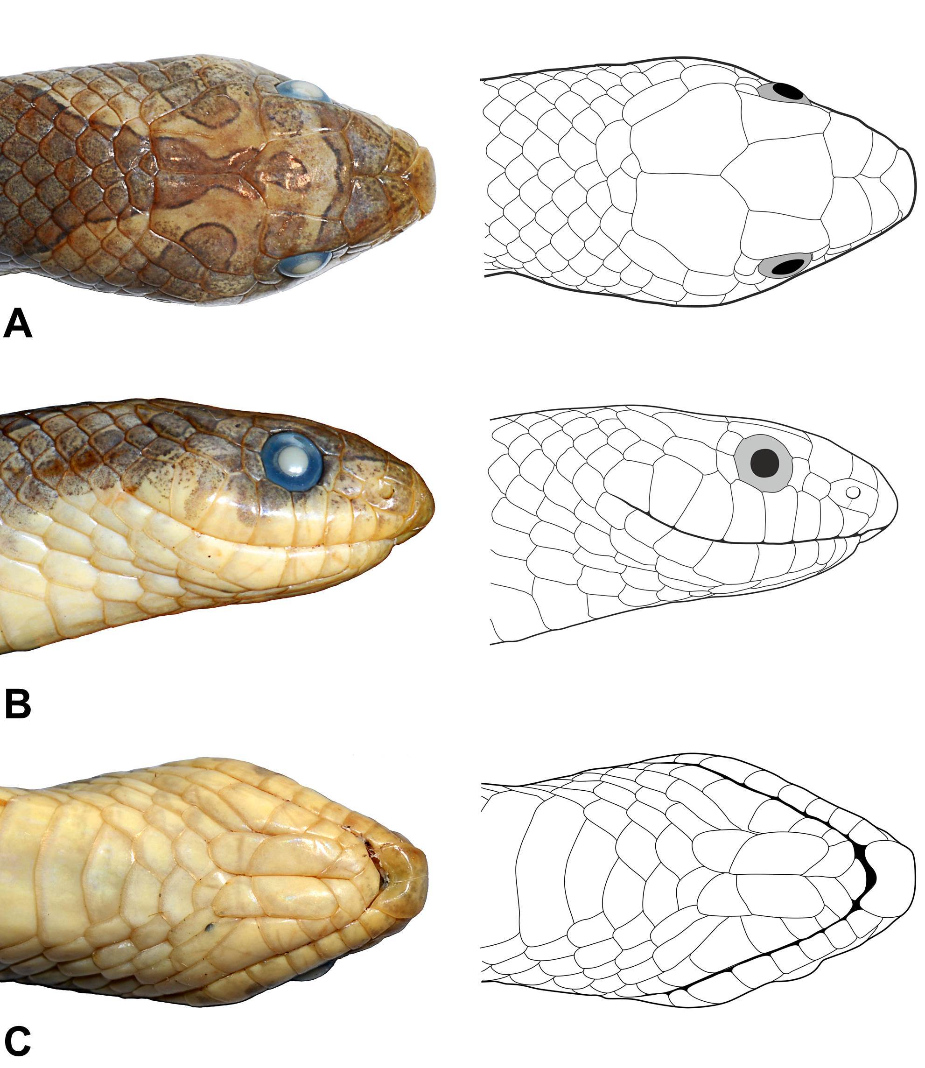

Fig. 1. Holotype (ZMMU R-13865) portraits and head scalation in dorsal (A), lateral (B), and ventral views (C). Photographs and drawings by Anna B. Vassilieva and Vitaly L. Trounov.
Coloration. In life. Body (see figure 2) is dull brownish gray; all dorsal scales scattered with minute dark brown spots; the three medial dorsal scale rows significantly less spotted, orange in color, with vertebral row slightly lighter, yellow-orange; 27 large transverse blotches on median dorsum, anterior six strongly waisted, butterfly-shaped, all posterior have slight medial notch on the anterior and posterior ends; each blotch bluish-gray in its center, getting darker toward the edges, forming a thin dark-brown to black margin; those blotches continue (5) on tail; very faint dark reticulated crossbar between each pair of dorsal spots, up to the 13th spot; some lateral dorsal scales dark brown, forming scarce speckling on flanks; gular and anterior ventral scales white, posterior ventrals with light pinkish tint; some ventrals bearing a subrectangular, diffuse gray spot on each lateral margin; on the posterior third of venter, this darker spotting becomes denser; subcaudals white, with few tiny grayish marginal spots present on the proximal quarter of the tail; sharp edge between white tail underside and dark gray lateral dorsals; tail cap cream.
The head is rusty-orange dorsally, with paler snout sides and dark-edged olive-gray markings with maroon tint on upper surface of the head; an U-shaped interocular bar, being as wide as long, covering prefrontals as well as parts of frontal, supraoculars, preoculars and internasals and extending to the upper angle of rostral; both supraoculars posteriorly bearing an irregular, diffuse rounded blotch; in the middle of the frontal there is a tear-shaped marking connected with the large arrow-shaped chevron extending from rear frontal and medial part of parietals to the occiput and nape; 1/1 temporal bar with sharp, dark-edged anterior end and diffuse posterior one, starting on lateral parietals and running down towards the neck behind the jaw angle; two short dark gray, oblique subocular stripes extend backwards from the lower margin of each orbit, the anterior being more prominent and covering the parts of IV, V and VI supralabials, and the posterior being paler and covering the parts of VI and VII supralabials.

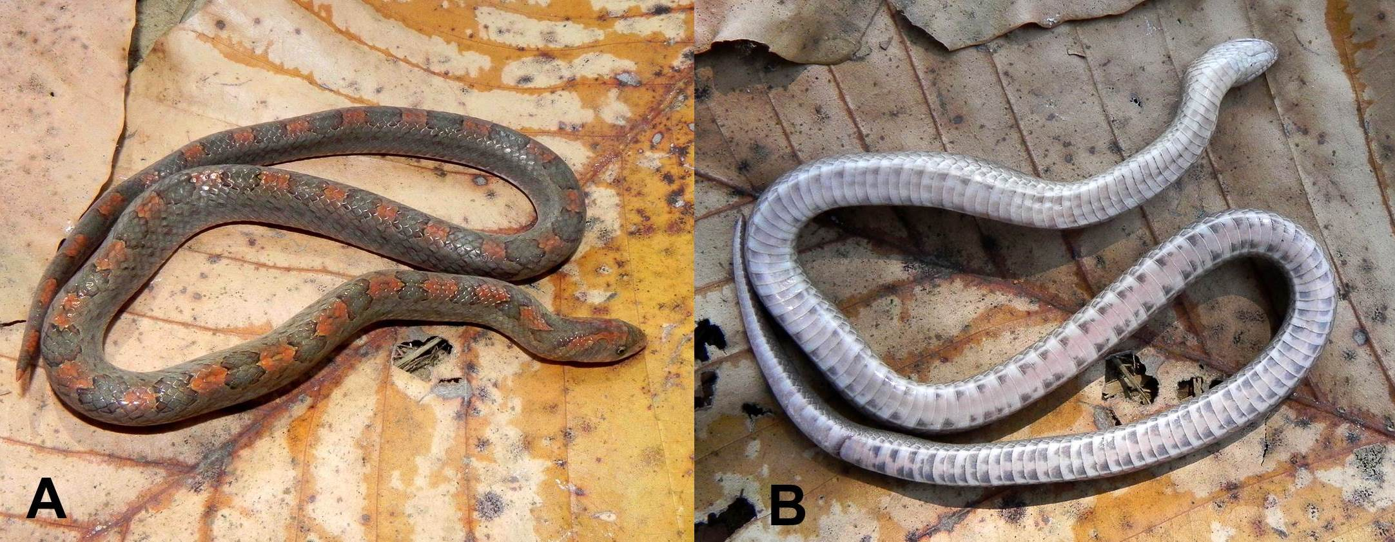
Fig. 2. Holotype (ZMMU R-13865) in life, dorsal (A) and ventral view (B). Photos by Anna B. Vassilieva.

In preservative. See figure 3. Body brownish-gray, vertebral region somewhat yellowish-beige; dorsal blotches and head markings dark gray, with a blackish margins; lateral speckling dark brown; throat, venter and tail undersides yellowish-cream, dark spots on ventral scales gray.

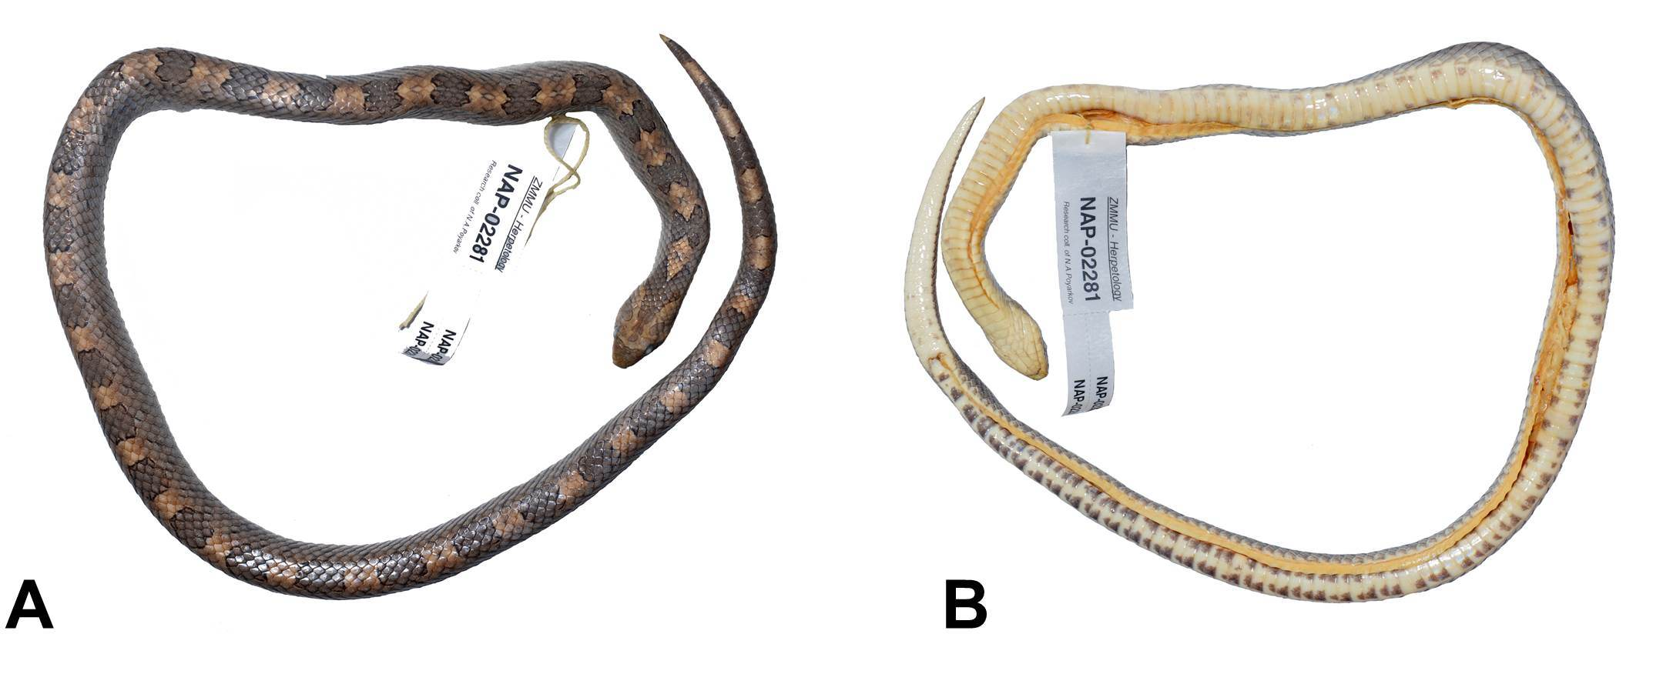
Fig. 3. Holotype (ZMMU R-13865) in preservative, dorsal (A) and ventral view (B). Photos by Anna B. Vassilieva and Vitaly L. Trounov.

Description and variation of the paratype series (figures 4, 5, 6)
External morphology. The most important characters of the available specimens, all belonging to the type series, appear in table 1 (Appendix). All other morphological characters agree with those described for the holotype.
Dentition. 8-10 functional maxillary teeth in all specimens, the three two being strongly enlarged and blade-like; developed palatine dentition.
Body scalation. All scales are smooth, small, ovoid; the lateralmost rows slightly enlarged, the vertebral row does not differ in size from other median dorsal rows. DSR: 17–17–15, without exception. Ventrals: 167–178, plus 1 (in one case 2) preventrals, strongly angulate; SC: 31-35, all paired; anal plate entire.
Head scalation. Generally as for holotype; in all specimens the entire nasals is subdivided below nostril by a thin shallow suture; single loreal and preocular, two postoculars, supralabials VI and V contacting eye; supralabials 8/8, infralabials 8/8 with one exception (7/7). Some variability observed in temporal scales, 1+2/1+2 being the most common condition (3 specimens), with primary (anterior) temporal being elongated subrectangular, secondary (posterior) upper temporal being elongated subrectangular approximately equal to the primary one, and lower secondary temporal being squarish, about half in length of the upper secondary temporal; the condition 1+1+2/1+1+2, with the two strongly elongated primary temporals being situated consecutively, observed in one specimen (ZFMK 88921); asymmetrical condition 2+3/2+2 in one specimen, with the upper primary (anterior) temporal representing elongated triangular scale shifted slightly anteriorly to the elongated subrectangular lower primary temporal, and the upper secondary (posterior) temporal on the right side of the skull divided on two smaller scales, anterior rounded and posterior triangular; asymmetrical condition 1+2/1+3 observed in one specimen, with the right side of skull similar to holotype and, on the left, with small squarish scale between primary and upper secondary temporal.
Coloration in life. The ground coloration varies from lighter and darker grey or brown in adults and subadult to light reddish-brown in young juveniles (see figure 4); 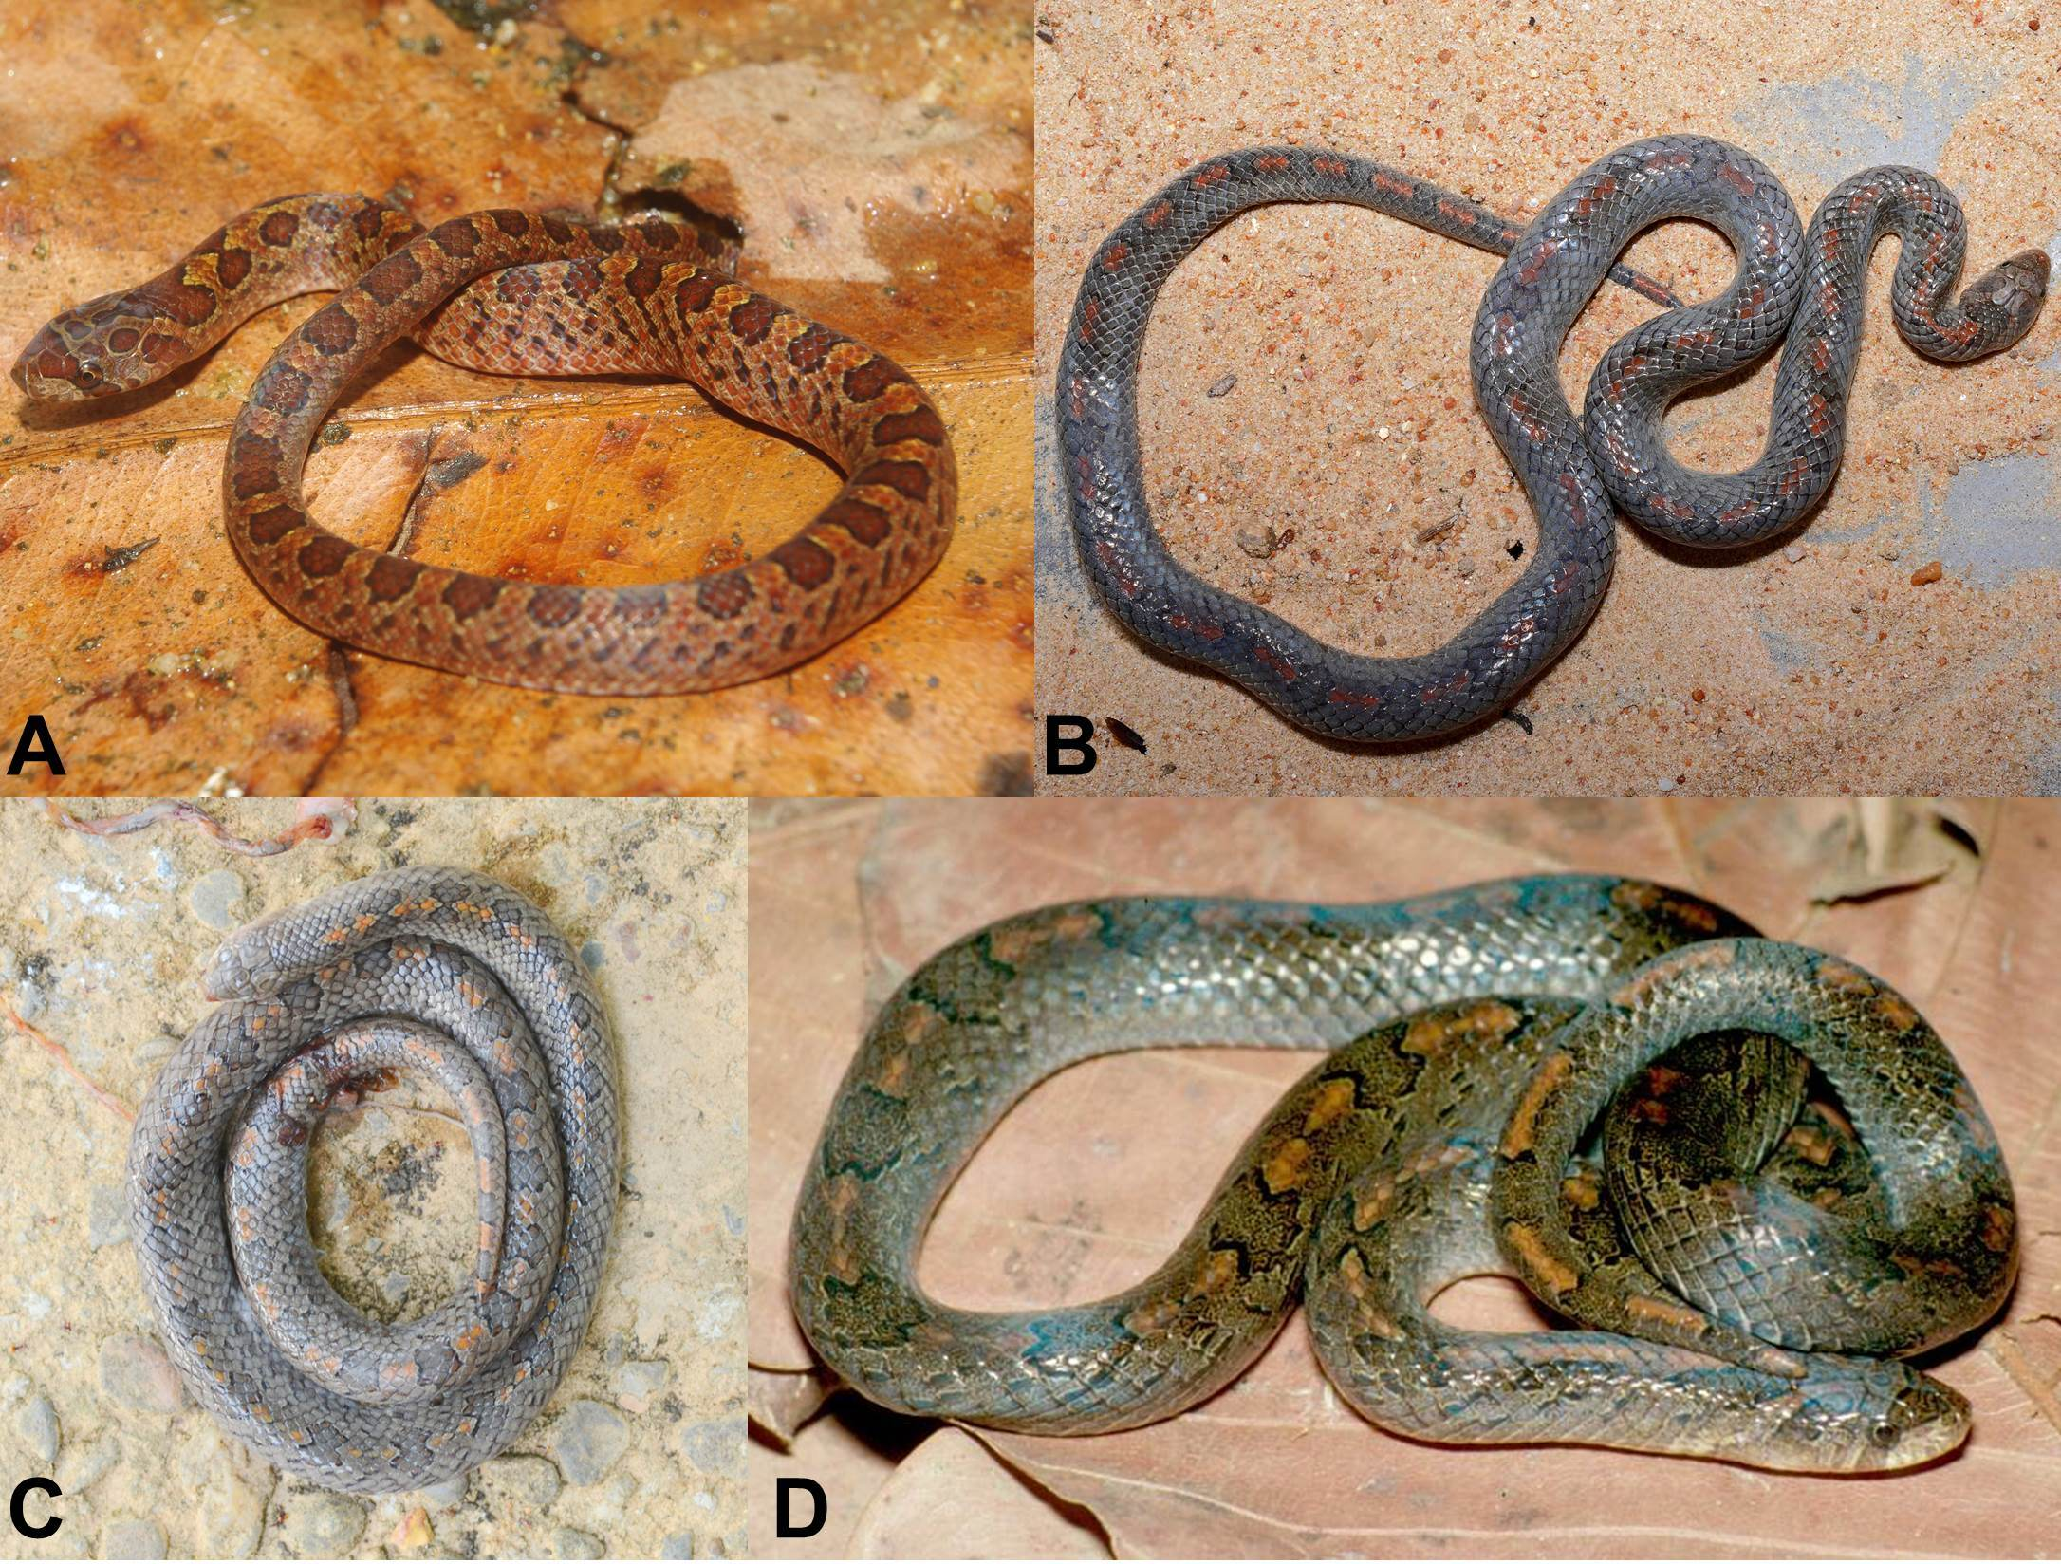
Fig. 4. Variation in life coloration of Oligodon lineomaculatus sp. nov. : (A) ZFMK 88921 (juvenile paratype); (B) ZMMU R-13866 (adult, male paratype); (C) ZMMU R-13815 (adult, male paratype); (D) uncollected adult specimen from Cat Tien National Park. Photos by Anna B. Vassilieva, Vitaly L. Trounov, Eduard A. Galoyan, Peter Geissler and ??.

The pattern is more or less consistent with the holotype, with some variations in dorsal blotch number on trunk (24-35, with 5 blotches on tail without exception), and in the width of light vertebral stripe from one to three middorsal scale rows. Dorsal spots dark bluish-gray in adults or subadults, more often with poor contrast (hardly distinguishible) with the ground dorsal coloration; dark brownish brick red with a contrast blackish margin in small juvenile. Head marking is more contrast in juvenile and subadult, in four specimens the frontal bears a rounded spot separated from the chevron marking. Head marking color is dark grey or olive-brown with maroon or rusty tint in adults and contrast brownish-red in juveniles. The color of the vertebral stripe varies from orange-yellow to red. Dark speckles on flanks may form oblique reticulated rows oriented back- and downwards. Ventral coloration varies from white with faint pinkish tint in adults to more saturated pink in subadults and bright red in juveniles (see figure 5);
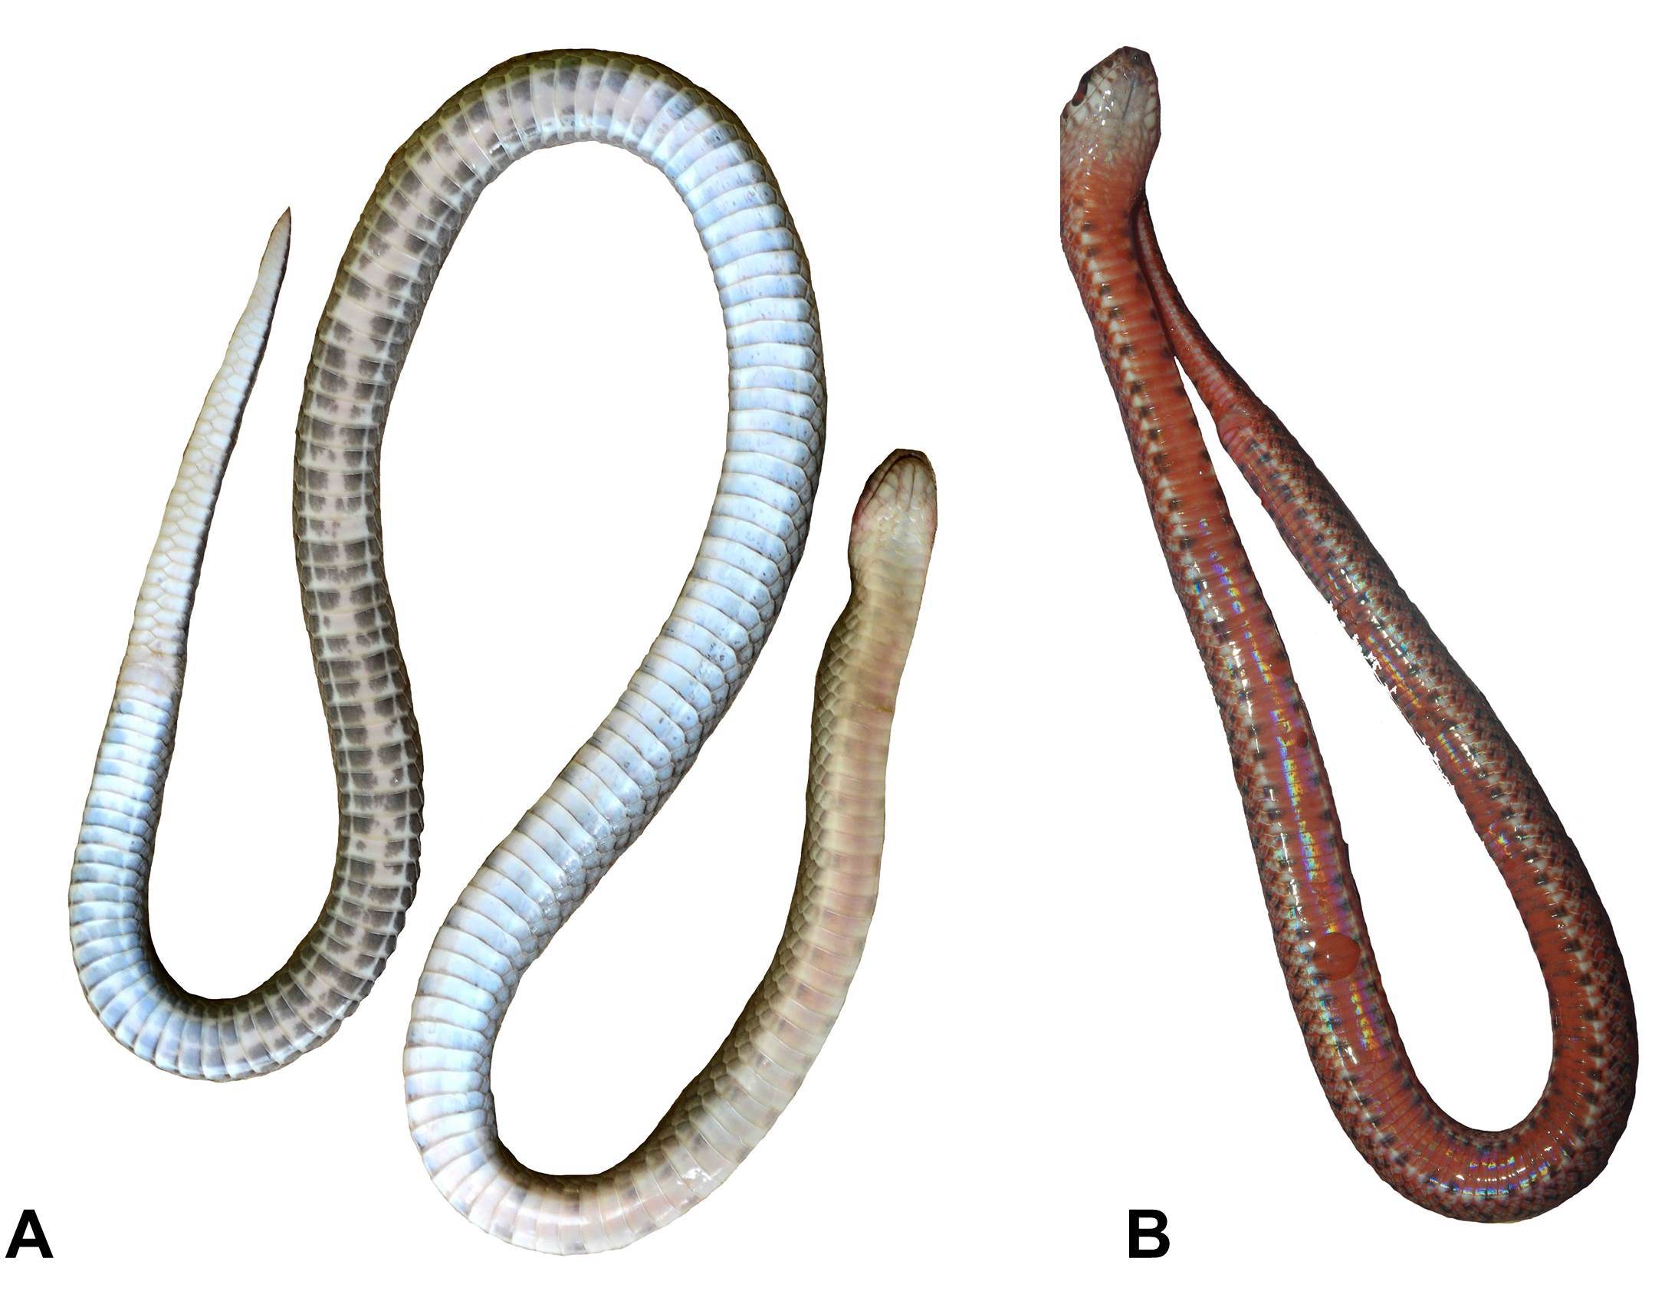
Fig. 5. Ventral coloration of Oligodon lineomaculatus sp. nov. in life: (A) adult male paratype (ZMMU R-13866); juvenile paratype (ZFMK 88921). Photos by Anna B. Vassilieva, Vitaly L. Trounov and Peter Geissler.

Ventral pattern varies from few squarish dark-grey spots on lateral edges of some ventrals to almost continuous dark grey spotting on most posterior ventrals; the throat and most anterior ventrals without dark spots; tail undersides without or with very few tiny dark speckles, only in the proximal part of the tail.
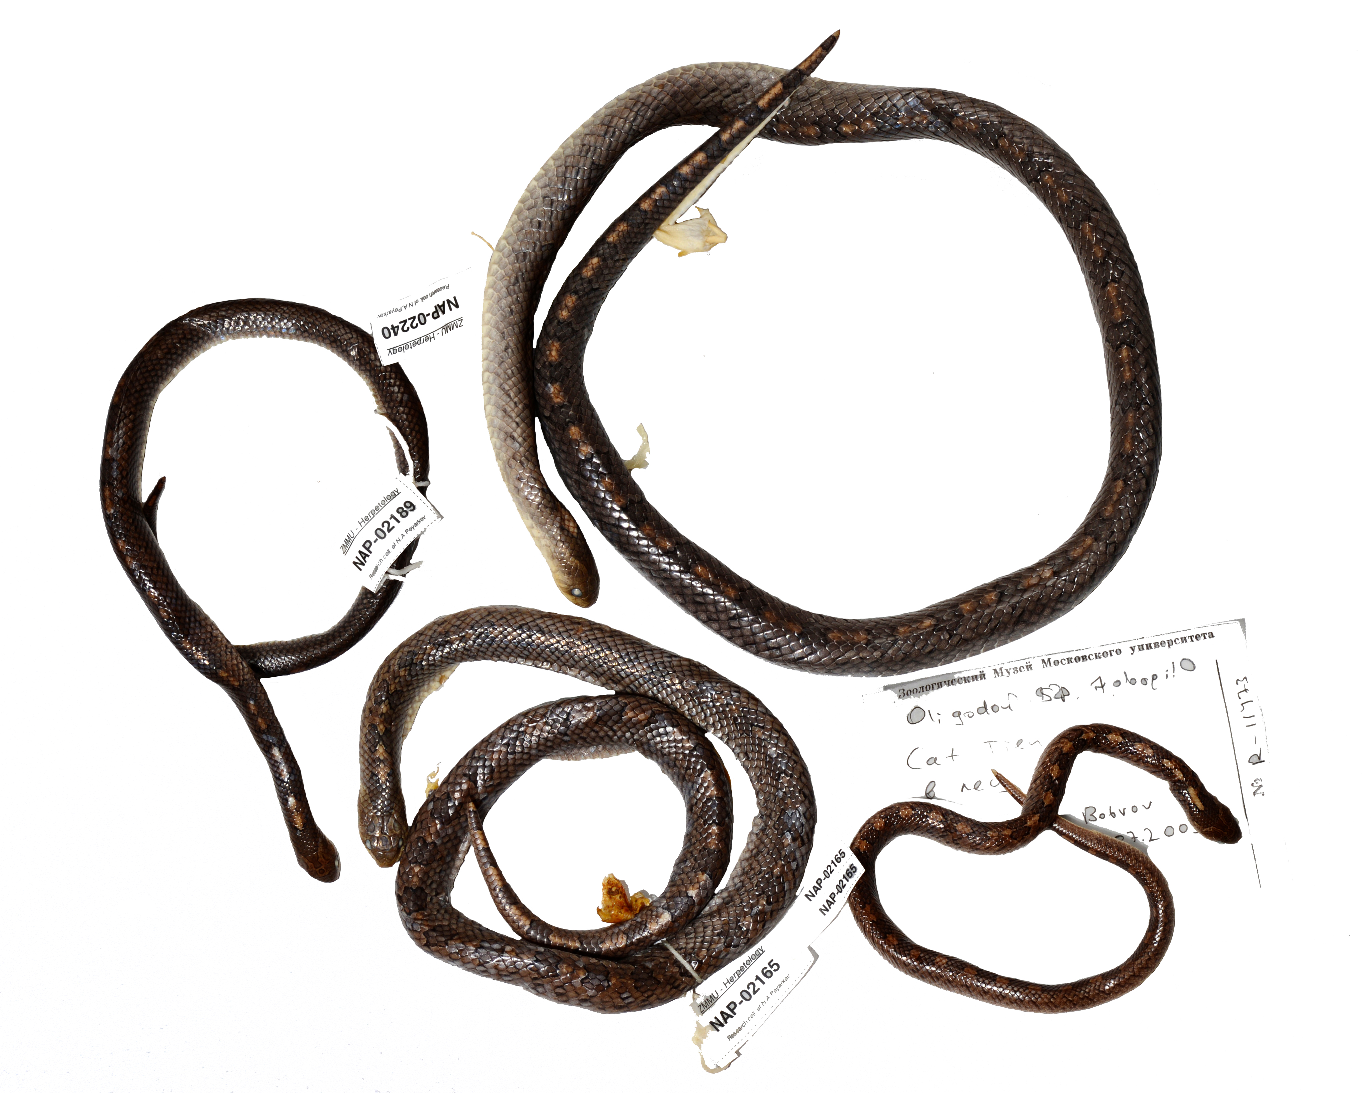
Fig. 6. Paratypes deposited in the herpetological collection of the Zoological Museums of Moscow State University (ZMMU) in preservative. Photos by Anna B. Vassilieva and Vitaly L. Trounov.

Hemipenis (dissected in preserved specimen – adult male ZMMU R-13866). The hemipenis is moderately long (reaching SC 11-12), bifurcate opposite to SC 7-8. The proximal part of the unforked part is covered with deep calyces and displays few longitudinal folds; the distal part is smooth, with thin and delicate longitudinal folds. Forks have faintly cellular surface. No spines or evident papillae (see figure 7).
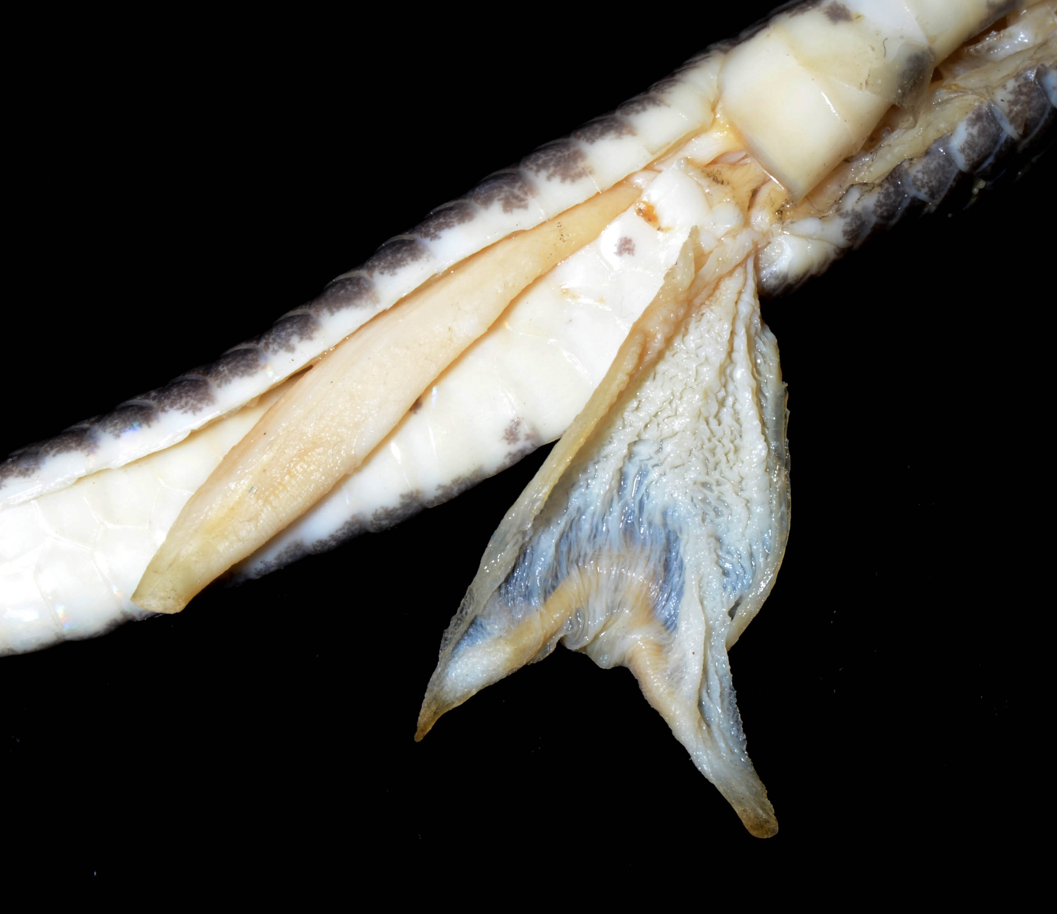
Fig. 7. Intact (left) and dissected (right) hemipenes in preserved paratype ZMMU R-13866. Photo by Anna B. Vassilieva and Vitaly L. Trounov.

Distribution. Known only from the type locality (Cat Tien National Park)
Habitat and natural history. Specimens ZMMU R-13865, R-13866 and R-13815 were collected on a country road running through highly disturbed lowland monsoon semidecidous, polydominant, partially submersible forest with the predominance of Lagerstroemia calyculata (Lythraceae), Tetrameles nudiflora (Datiscaceae), Dipterocarpus alatus (Dipterocarpaceae), Ficus spp. (Moraceae) and Afzelia xylocarpa (Fabaceae) and with a canopy formed by different arboreal species of Anacardiaceae, Lauraceae, Irvingiaceae, Meliасeae, Myrtaceae, Moraceae and Euphorbiaceae. Forest edges along the road are formed by bamboo (Dendrocalamus sp.; Poaceae), rattan (Calamus sp., Arecaceae), trees (Terminalia calamansanai, Combretaceae; Hibiscus sp., Malvaceae; Grewia sp., Tiliaceae; etc.), lianas (Acanthaceae, Mimosaceae, Verbenaceae, etc.) and herbaceous plants (Zingiber sp., Zingiberaceae; Saccharum sp., Poaceae; etc.). One specimen (ZMMU R-13815) was collected on the forest trail in an almost undisturbed area of monsoon semidecidous forest with a strong predominance of Lagerstroemia calyculata and Tetrameles nudiflora.
Three living specimens were collected on the ground, being active during day time.
The digestive tracts of specimens ZMMU R-13866 and R-13815 contained chitinous remains of digested insects, presumably coleopterans and blattodeans.
Etymology. The specific epithet lineomaculatus reflects the characteristic dorsal color pattern of the new species, being composed of a vertebral stripe interrupted by dark spots.
Comparisons. Beside the hemipenial characters, which are not available in all species (Green 2010) we use the number of dorsal scale rows at midbody (MSR) as a major diagnostic character for comparison (fide David et al. 2008 a + b). We compare Oligodon lineomaculatus sp. nov. (MSR = 17) with all (distributional notes are provided for species, which are not known to occur within the Indochinese biogeographical region fide Bain & Hurley 2012) congeners having 15 to 17 MSR, as the number of MSR may vary between this two values due to the position of the dorsal scale row reduction (David et al. 2012). Among those, Oligodon sp. nov. differs from:
O. affinis Günther, 1862 from India by a higher number of ventrals (167-178 vs. 129-145) and an undivided nasal; O. ancorus (Girard, 1858) from the Philippines by a higher number of vertebral blotches (24-35 +5 vs. 14-22), and a red ventral coloration in juveniles (yellowish cream in O. ancorus); O. annulifer (Boulenger, 1893) from Borneo by an entire nasal, a higher number of VEN (167-178 vs. 151-162), a lower number of SC (31-35 vs. 44-50), and 8 (rarely 7 IL) instead of 7 SL and IL; O. arnensis (Shaw, 1802) from the Indian Subcontinent by an entire nasal, 8 (rarely 7 IL) instead of 7 SL and IL, and an entire anal plate; O. barroni (Smith, 1916) by an entire nasal, a higher number of VEN (167-178 vs. 135-160), 24-35+5 vs. 10-14 transverse paravertebral blotches; O. bitorquatus Boie, 1827 from Indonesia by an entire nasal, 8 (rarely 7 IL) instead of 7 SL and IL, and the absence of a bright yellow collar between the temporal bars and the chevron; O. booliati Leong & Grismer, 2004 from Pulau Tioman by an entire nasal, 2 instead of 1 PosOc, a higher number of VEN (167-178 vs. 143-153), and a lower number of SC (31-35 vs. 54-60); O. brevicauda Günther, 1862 from India by an entire nasal, the presence of a loreal, 8 (rarely 7 IL) instead of 7 SL and IL, and the presence of dark vertebral blotches; O. chinensis Günther, 1888 by an entire nasal, the presence of temporal bars, 24-35+5 large transverse blotches instead of 10-15+3-4 black crossbands, and the red ventral color in juveniles (greyish white in O. chinensis); O. cinereus Günther, 1864 by an entire nasal, by a head bearing prominent dark markings (temporal bars, chevron, interocular bar), and a red ventral coloration in juveniles (white to yellowish cream in O. cinereus) [Bourret (1934d) described Simotes violaceus pallidocinctus from Saigon. This name “pallidocinctus” is currently recognized as a color form of O. cinereus (See Green 2010, David et al. 2012). This color form occurs syntopically with Oligodon lineomaculatus sp. nov. and is distinguishable by its characteristic 27-34+3-4 light, black edged thin crossbars and unspotted ventrals]; O. cruentatus Günther, 1868 from Southern Myanmar by an entire nasal, and a divided anal plate; O. deuvei David, Vogel & Rooijen, 2008 by an entire nasal, 1 instead of 2 PreOc, absence of a light vertebral line edged by two darker dorsolateral lines, and a reddish ventral color in juveniles (only ventral tail being red in O. deuvei); O. dorsalis (Gray & Hardwicke, 1835) from Assam, Bhutan, Bangladesh and Myanmar by 2 instead of 1 PosOc, 8 (rarely 7 IL) instead of 7 SL and IL, and an undivided anal plate; O. erythrogaster Boulenger, 1907 from India and Nepal by the presence of a loreal, 8 (rarely 7 IL) instead of 7 SL and IL, an entire anal plate, and the presence of transverse vertebral blotches; O. erythrorhachis Wall, 1910 from India by the presence of a loreal, an entire anal plate, a higher number of VEN (167-178 vs. 154), and a lower number of SC (31-35 vs. 46); O. everetti Boulenger, 1893 from Borneo by an entire nasal, 8 (rarely 7 IL) instead of 7 SL and IL, a higher number of VEN (167-178 vs. 132-154), and a lower number of SC (31-35 vs. 46-72); O. forbesi Boulenger, 1883 from Indonesia by an entire nasal, a lower number of SC (31-35 vs. 43-51), the presence of an ocular bar and a reddish ventral color in juveniles (yellowish in O. forbesi); O. formosanus Swinhoe, 1863 by an entire nasal, a reddish ventral coloration in juveniles (yellowish with a white ventrolateral line in O. formosanus), and the presence of dark transverse vertebral blotches; O. hamptoni Boulenger, 1918 from Myanmar by the presence of two internasals, 8 instead of 5 SL, 8 (rarely 7 IL) instead of 6 IL, and an entire anal plate; O. inornatus Boulenger, 1914 by an entire nasal, the presence of prominent head markings (chevron, temporal bars and ocular bar), and the presence of 24-35+5 large vertebral blotches (head and body uniformely pale brown in O. inornatus); O. jintakunei Pauwels, Wallach, David & Chanhome, 2002 from Thailand by an entire nasal, presence of 2 internasals, 2 instead of 1 PosOc, and an entire anal plate; O. joynsoni (Smith, 1917) by an entire nasal, a lower number of VEN (167-178 vs. 187-195) and of SC (31-35 vs. 40-50); O. kampucheaensis Neang, Grismer & Daltry, 2012 by an entire nasal, and 24-35+5 large vertebral blotches instead of 17 thin whitish transverse bands; O. kheriensis Acharji & Ray, 1936 from India by a lower number of VEN (167-178 vs. 196), the presence of a chevron as well as the presence of vertebral blotches (dorsum being uniformly colored in O. kheriensis); O. kunmingensis Kou & Wou, 1993 from China by an entire nasal, the presence of a loreal, 8 instead of 5 SL, 8 (rarely 7 IL) instead of 6 IL, and a higher number of VEN (167-178 vs. 108-121); O. lacroixi Angel & Bourret, 1933 by the presence of 2 internasals, the presence of a loreal, 8 instead of 5 SL, 8 (rarely 7 IL) instead of 6 IL, and an entire anal plate; O. lungshenensis Zheng & Huang, 1978 from China by the presence of two intranasals, the presence of a loreal, 8 (rarely 7 IL) instead of 6 SL and IL, and an entire anal plate; O. macrurus Angel, 1927 by an entire nasal, a higher number of VEN (167-178 vs. 139-162), and a lower number of SC (31-35 vs. 45-94); O. maculatus Taylor, 1918 from the Philippines by 8 (rarely 7 IL) instead of 7 SL and IL, a higher number of VEN (167-178 vs. 156-164) and a lower number of SC (31-35 vs. 52-55); O. melaneus Wall, 1909 from India by an entire anal plate, a higher number of VEN (167-178 vs. 152-160) and a lower number of SC (31-35 vs. 39-40); O. melanozonatus Wall, 1922 from India and China by the presence of a loreal, 8 (rarely 7 IL) instead of 6 SL and IL (7 SL present in one specimen of O. melanozonatus), and by an entire anal plate; O. meyerinkii (Steindachner, 1891) from the Philippines and Borneo by an entire nasal, by 8 (rarely 7 IL) SL and IL (6 SL and 7 IL in O. meyerinkii ), and by the absence of paravertebral stripes; O. modestus Günther, 1864 from the Philippines by 2 instead of 1 PosOc, by 8 SL and IL (6 SL and 7 IL in O. modestus), and by the presence of large transverse blotches on dorsum; O. moricei David, Vogel & Rooijen, 2008 by an entire nasal, by a reddish to greyish dorsal coloration with large transverse blotches instead of a dark greyish brown color with only a lighter vertebral line, and a reddish venter (in juveniles) instead of a yellowish one in O. moricei; O. mouhoti Günther, 1864 by an entire nasal, and the absence of a light vertebral line flanked by brown lines (vertebral line interrupted by dark transverse blotches in O. lineomaculatus sp. nov; O. multizonatus Zhao & Jiang, 1981 from China by an entire nasal, by a short loreal not touching the eye, a lower number of VEN (167-178 vs. 190-195) and SC (31-35 vs. 68-75), and an entire anal plate; O. nagao David, Nguyen, Nguyen, Jinag, Chen, Teynié & Ziegler, 2012 by 1 instead of 2 PreOc, and a reddish coloration of venter and dorsum (in juveniles); O. nikhili Whitaker & Dattari, 1982 from India by an entire nasal, the presence of a loreal, a higher number of VEN (167-178 vs. 144), and an entire anal plate; O. notospilus Günther, 1873 from the Philippines by a higher number of VEN (167-178 vs. 136-140); O. octolineatus (Schneider, 1801) from Malaysia, Singapore and Indonesia by an entire nasal, the absence of alternating longitudinal stripes on dorsum, and the presence of a broad V-shaped chevron; O. ornatus Van Denburgh, 1909 from Taiwan and China by the presence of a loreal, 8 (rarely 7 IL) instead of 7 SL and IL, and an entire anal plate; O. perkinsi (Taylor, 1925) from the Philippines by a lower number of VEN (167-178 vs. 183-188), and by the presence of prominent head markings (ocular bar, temporal bars and chevron); O. petronellae Roux, 1914 from Sumatra by 8 (rarely 7 IL) instead of 7 IL and SL, a higher number of VEN (167-178 vs. 144-163), and the absence of 20-25+3-5 lighter rings; O. praefrontalis Werner, 1913 from Indonesia by the presence of 2 internasals and a loreal, 2 instead of 1 PosOc, a lower number of VEN (167-178 vs. 193), and an entire anal plate; O. propinquus Jan, 1862 from Indonesia by 8 (rarely 7 IL) instead of 7 SL and IL, 167-178 vs. 140 VEN, and the presence of distinct head markings (ocular bar, temporal bars and chevron); O. pseudotaeniatus David, Vogel & Rooijen, 2008 from Thailand by an entire nasal, a higher number of VEN (167-178 vs. 137-156), and the presence of dark transverse blotches on dorsum; O. pulcherrimus Werner, 1909 from Sumatra by an entire nasal, and an entire anal plate; O. saintgironsi David, Vogel & Pauwels, 2008 by an entire nasal, 1 vs. 2 PreOc, 31-35 vs. 53-59 SC, and 24-35+5 vs. 10-13+2-4 large transverse blotches on dorsum; O. signatus (Günther, 1864) from Malaysia, Singapore and Indonesia by an entire nasal, 2 vs. 1 PosOc, and 31-35 vs. 43-59 SC; O. sublineatus Duméril, Bibron & Duméril, 1854 from Sri Lanka by an entire nasal, an entire anal plate, and 8 (rarely 7 IL) vs. 7 SL and IL; O. taeniolatus (Jerdon, 1853) from the Indian Subcontinent, Iran, Afghanistan, Turkmenistan and Sri Lanka by an entire nasal, and an entire anal plate; O. templetoni (Linnaeus, 1758) from Sri Lanka by an entire nasal, 167-178 vs. 127-152 VEN, and an entire anal plate; O. theobaldi (Günther, 1868) from Assam and Myanmar by an entire nasal, an entire anal plate, and the absence of longitudinal lateral lines; O. torquatus (Boulenger, 1888) from Myanmar by an entire anal plate, and the absence of 4 dark longitudinal stripes on dorsum; O. travancorius Beddome, 1877 from India by an entire nasal, the presence of a loreal, a higher number of VEN (167-178 vs. 145-155), and an entire anal plate; O. trilineatus (Duméril, Bibron & Duméril, 1854) from Sumatra region by an entire nasal, 2 vs. 1 PosOc, 167-178 vs. 145-162 VEN, 31-35 vs. 39-62 SC, and the presence of dark transverse blotches on dorsum; O. unicolor (Kopstein, 1926) from Indonesia by an entire nasal, 8 vs. 6 SL, and the presence of large dorsal blotches; O. venustus (Jerdon, 1853) from India by an entire anal plate, and 8 (rarely 7 IL) vs. 7 SL and IL; O. vertebralis (Günther, 1865) from Borneo and the Philippines by an entire nasal, 8 (rarely 7 IL) vs. 7 SL and IL, and by a higher number of VEN (167-178 vs. 136-154); O. waandersi (Bleeker, 1860) from Sulawesi Archipelago by the absence of a prominent reddish vertebral line on tail; O. wagneri (David & Vogel, 2012) from Pulau Nias by an entire nasal, by 24-35+5 large transverse dorsal blotches instead of 14 narrow white crossbars, and by a reddish venter (in juveniles); O. woodmasoni (Sclater, 1891) from Andaman and Nicobar Islands by an entire nasal, 167-178 vs. 180-190 VEN, and a lower number of SC (31-35 vs. 46-57). Comparative Data used in this paragraph are based on: Green 2010, Green et al. 2010, David et al. 2008 a & b., David et al. 2012, David & Vogel 2012, Neang et al. 2012, Cambden-main 1970, Saint Girons 1972, Deuve 1970, Geissler et al. 2011, 2012, Murthy et al. 1993.
Discussion
Beside the 21 valid species, which are known to occur in Indochina (see table 2), and from which Oligodon lineomaculatus sp. nov. differs in its combination of diagnostic characters, an additional available Oligodon species name for the region has to be discussed in this context. Bourret (1934) described Simotes taeniatus caudaensis based on three specimens collected in “Cauda” now Cau Da, near Nha Trang, Khán Hoa Province, Vietnam. Later on this species was synonomyzed with Oligodon barroni by Smith (1943: p. 210). David et al. (2008b) affirmed this taxonomic decision after having reexamined syntypes of both taxa (selected traits, based on David et al. (2008b) are shown in table 2). Oligodon lineomaculatus sp. nov. does share some similarities with the description of Simotes taeniatus caudaensis (see also Bourret (1936), like a red belly in life (in juveniles of O. lineomaculatus sp. nov.), and dark butterfly shaped vertebral blotches. Nevertheless Oligodon lineomaculatus sp. nov. differs from Oligodon barroni (including the traits of syntypes of S. t. caudaensis), as it is mentioned in the comparison paragraph an in table 2.
Based on the hemipenial morphology, which is lacking spines or papillae we suggest O. lineomaculatus sp. nov. to be a member of the Oligodon cyclurus – group (sensu Smith 1943, David et al. 2008 a, and Neang et al. 2012), comprising: O. cyclurus, O. chinensis, O. kheriensis, O. juglandifer, O. formosanus, O. ocellatus, O. fasciolatus, O. kampucheaensis, O. saintgironsi and O. macrurus. Future genetic comparison has to proof this systematic assignment.
The new species is the fifth Oligodon species known within the borders of the Cat Tien National Park. Geissler et al. (2011) erroneously listed the paratype (ZFMK 88921) of Oligodon lineomaculatus sp. nov., together with other specimens under the name Oligodon cinereus. Currently, the following species (determination based on specimens housed in the collections of ZFMK, ZMMU, IEBR, see Appendix) are known to occur sympatrically within the lowland forests of the Cat Tien National Park : O. cinereus, O. saintgironsi, O. ocellatus, O. deuvei and O. lineomaculatus sp. nov.. A further record of Oligodon fasciolatus by Nguyen & Ho (2002) from Cat Tien can currently not be affirmed, because of the lack of voucher specimens.

Acknowledgments. We thank the Administration of the Cat Tien National Park and personally the director, Dr. Nguyen Van Dien as well as his antecessor Tran Van Thanh for the possibility to conduct this research. All fieldworks were conducted under Agreement № 37/HD about scientific cooperation between Cat Tien National Park and Joint Russian-Vietnamese Tropical Research and Technological Center for the period 2008-2012. We thank the administration of the Tropical Center and personally Dr. Nguyen Van Hue, Vu Manh and Nguyen Van Thinh for the help in organizing the fieldwork. We gratefully acknowledge
Le Xuan Canh, Ta Huy Thinh (IEBR, Hanoi) for their support and the loan of specimens. We are grateful to Paul Moler for providing scientific material and photographs. We thank Gernot Vogel and Patrick David for their taxonomic advice. We are grateful to Dr. V.L. Trunov for the help in preparation photographic illustrations and I. Palko, Jendrian Riedel, Le Duc Khanh, Alexander Krohn, Bernd Geissler, Rike Bach and A. Borisanova for assistance in the field. The study was supported by the Russian Foundation of Basic Research (Grant No. RFFI-12-04-33150_mol_a_ved). Field work of PG was supported by the German Society for Herpetology and Herpetoculture and the Alexander Koenig Gesellschaft. PG especially thanks Thomas Ziegler and Nguyen Quang Truong for their supervision, as well as administrative and ideal support.

References
Bain, R.H. & Hurley, M.M. (2011) A biogeographic syntheses of the amphibians and reptiles of Indochina. Bulletin of the American Museum of Natural History, 360, 1-138.
Bourret, R. (1934) Notes Herpétologiques sur l'Indochine Française. IV. Sur une collection
d'Ophidiens de Cochinchine et de Cambodge. V. Sur Liopeltis major et ses alliés. Bulletin Général De L'Instruction Publique, 13–30.
Bourret, R. (1936) Les Serpents de L’Indochine. Imprimerie Henri Basuyau & Cie., Toulouse. Vol. I, 141pp; Vol. II, 505pp. (in French)
Campden-Main, S.M. (1970) The identity of Oligodon cyclurus (Cantor, 1839) and revalidation of Oligodon brevicauda (Steindachner,1867) (Serpentes: Colubridae). Proceedings of the Biological Society of Washington, 82 (58), 763–766.
Coleman, K., Rothfuss, L.A., Ota, H. & Kardong, K.V. (1993). Kinematics of egg-eating by the
specialized Taiwan snake Oligodon formosanus (Colubridae). Journal of Herpetology,
27, 320–327.
David, P. & Vogel, G. (2012) A new species of the genus Oligodon Fitzinger, 1826 (Squamata: Colubridae) from Pulau Nias, Indonesia. Zootaxa, 3201, 58–68.
David, P., Das, I. & Vogel, G. (2011) On some taxonomic and nomenclatural problems in Indian species of the genus Oligodon Fitzinger, 1826 (Squamata: Colubridae). Zootaxa, 2799, 1–14.
David, P., Nguyen, T.Q., Nguyen, T.T., Jiang, K., Chen, T., Teynié, A. & Ziegler, T. (2012) A new species of the genus Oligodon Fitzinger, 1826 (Squamata: Colubridae) from northern Vietnam, southern China and central Laos. Zootaxa, 3498, 45–62.
David, P., Vogel, G. & Pauwels, O.S.G. (2008a) A new species of the genus Oligodon Fitzinger, 1826 (Squamata: Colubridae) from southern Vietnam and Cambodia. Zootaxa, 1939, 19–37.
David, P., Vogel, G. & Rooijen, J.van. (2008b) A revision of the Oligodon taeniatus (Günther, 1861) (Squamata: Colubridae) group, with the description of three new species from the Indochinese Region. Zootaxa, 1965, 1–49.
Deuve, J., (1970) Serpents du Laos. Mémoires Office de la Recherche Scientifique et Technique
Outre-Mer, 39, 1–251. (in French).
Dowling, H.G. (1951) A proposed standard system of counting ventrals in snakes. British Journal of Herpetology, 1 (5), 97–99.
Dowling, H.G. & Savage, J.M. (1960) A guide to the snake hemipenis: a survey of basic structure and systematic characteristics. Zoologica, 45, 17–28.
Geissler, P., Nguyen, Q.T., Poyarkov, N.A. & Böhme, W. (2011) New records of snakes
from Cat Tien National Park, Dong Nai and Lam Dong provinces, southern Vietnam. Bonn zoological Bulletin, 60(1), 9-16.
Geissler, P., Krohn, A.R. & Rennert, A. (2012) Herpetofaunal records in coastal dune areas, Binh Thuan Province, Southern Vietnam, with the rediscovery of Oligodon macrurus Angel, 1927. Russian Journal of Herpetology, 18 [2011] (4), 317–324.
Green, M.D. (2010) Molecular phylogeny of the snake genus Oligodon (Serpentes:Colubridae), with an annotated checklist and key. Unpublished Master thesis, University of Toronto, 161 pp.
Green, M.D., Orlov, N.L. & Murphy, R.W. (2010) Toward a Phylogeny of the Kukri Snakes, Genus Oligodon. Asian Herpetological Research, 1(1), 1–21.
Kaiser, H., Crother, B., Kelly, C.M.R., Luiselli, L., Ota, H., Passos, P., Schleip, W.D., Wüster, W., (2013) Best practices: in the 21st century, taxonomic decisions in herpetology are acceptable only when supported by a body of evidence and published via peer-review. Herpetological Review, 44(1), 8–23.
Leviton, A.E. (1953) A new snake of the genus Oligodon from Annam. Journal of the Washington Academy of Science, 43(12), 422–424.
Leviton, A.E. (1960). Notes on the second specimen of the snake Oligodon annamensis Leviton.
Wasaman Journal of Biology, 18, 305–307.
Minton, S.A., Anderson, J.A. (1963). Feeding habits of the kukri snake, Oligodon taeniolatus.
Herpetologica, 19, 147.
Murthy, T.S.N., Sanyal, D.P., Duttagupta, B. (1993). Rare snakes of India. Snake, 25, 135–140.
Neang, T., Grismer, L.L. & Daltry, J.C. (2012) A new species of kukri snake (Colubridae: Oligodon Fitzinger, 1826) from the Phnom Samkos Wildlife Sanctuary, Cardamom Mountains, southwest Cambodia. Zootaxa, 3388, 41–55.
Nguyen, V.S. & Ho, T.C. (2002) Species composition of the herpetofauna recorded in the Cat Tien National Park. Journal of Biology, 24: 2–10. (in Vietnamese).
Saint Girons, H. (1972) Les serpents du Cambodge. Mémoires du Muséum National d’Histoire Naturelle. Nouvelle Serie A, Zoologie, 74, 1–170.
Smith, M.A. (1943) The Fauna of British India, Ceylon and Burma, including the whole of the Indo-chinese subregion. Reptilia and Amphibia. Vol. III, Serpentes. Taylor & Francis, London, xii + 583 pp.
Wagner, F.W. (1975) A revision of the Asian colubrid snakes Oligodon cinereus (Günther), Oligodon joynsoni (Smith), and Oligodon cyclurus (Cantor). Unpublished Master's thesis, Baton Rouge, Louisiana State University, 97 pp.

APPENDIX
Specimens examined
O. macrurus: ZFMK 88884 (female); ZFMK 88885 (male)
O. ocellatus ZFMK 88920
O. saintgironsi ZFMK 88919

Table 1: Morphological traits (A) and pholidosis (B) of the type series of Oligodon lineomaculatus sp. nov.; juv. = juvenile; sad = subadult; m = male; f = female; further abbreviations are listed in the material and methods paragraph.
A
Specimen | ASR | MSR | PSR | SL | IL | Teeth | Nasal | Anal | PreOc | LOR | PstO | Temp | VEN | SC | Main dorsal pattern  (body + tail)
ZMMU  R-11473 | 17 | 17 | 15 | 8 | 8 | 8/9 | E | E | 1 | 1 | 2 | 1+2/1+2 | 173 | 31 | 31 + 5 dark blotches;  light vert. line
ZMMUR-13815 | 17 | 17 | 15 | 8 | 8 | 10/9 | E | E | 1 | 1 | 2 | 2+3/2+2 | 170 | 35 | 35 + 5 dark blotches;  light vert. line
ZMMUR-13815 | 17 | 17 | 15 | 8 | 7 | 10/8 | E | E | 1 | 1 | 2 | 1+2/1+2 | 168 | 32 | 24 + 5 dark blotches;  light vert. line
ZMMUR-13866 | 17 | 17 | 15 | 8 | 8 | 8/9 | E | E | 1 | 1 | 2 | 1+2/1+3 | 178 | 32 | 31 + 5 dark blotches;  light vert. line
ZFMK 88921 | 17 | 17 | 15 | 8 | 8 | 10/10 | E | E | 1 | 1 | 2 | 1+1+2/1+1+2 | 169 | 31 | 33+5 dark blotches;  light vert. line
ZMMUR-13865  holotype | 17 | 17 | 15 | 8 | 8 | 10/8 | E | E | 1 | 1 | 2 | 1+2/1+2 | 167 | 32 | 27 + 5 dark blotches;  light vert. line

B
Specimen | Sex/age | TL | SVL | TaL | TaL/TL | HW | HL | HH | IO | ED | SnL | EN | IN | SL, contacting eye
ZMMU R-11473 | ?/ juv | 255.0 | 228.0 | 27.0 | 0.11 | 8.1 | 9.6 | 6.8 | 4.7 | 2.0 | 3.4 | 1.8 | 2.9 | IV-V
ZMMU R-13815 | m/ ad | 465.0 | 407.5 | 57.5 | 0.12 | 10.3 | 11.6 | 6.7 | 5.5 | 2.4 | 4.4 | 2.4 | 4.1 | IV-V
ZMMU R-13815 | f/ sad | 365.0 | 324.5 | 40.5 | 0.11 | 8.6 | 10.1 | 7.2 | 5.4 | 2.1 | 3.8 | 2.2 | 3.6 | IV-V
ZMMU R-13866 | m/ ad | 590.0 | 525.0 | 65.0 | 0.11 | 10.8 | 13.2 | 9.6 | 6.7 | 2.6 | 4.8 | 2.9 | 4.5 | IV-V
ZFMK 88921 | ?/ juv | 170.0 | 152.0 | 18.2 | 0.11 | 6.7 | 9.7 | 4.2 | 4.1 | 1.65 | 3.3 | 1.8 | 2.8 | IV-V
ZMMU R-13865  holotype | m/ ad | 415.0 | 362.0 | 53.0 | 0.13 | 9.9 | 12.2 | 7.9 | 5.9 | 2.4 | 4.6 | 2.3 | 4.0 | IV-V

Table 2: Comparison of morphological and pattern characters of all Oligodon species known to occur in Indochina (Cambodia, Laos and Vietnam), according to David et al. (2008 a,b), Nguyen et al. (2009), Teynié & David (2010), David et al.(2012) and Neang et al (2012). Data are compiled based on Bourret (1936), Smith (1943), Campden-Main (1970), Deuve (1970), Saint Girons (1972), David et al. (2008a, b), Green (2010), Geissler et al (2011), David et al. (2012), Neang et al. (2012), and own examinations (see : specimens examined). An explanation of abbreviatins is provided in Methods and material. Rare counts are given in brackets, D means divided, E means entire, pattern counts are devided in body + tail.
Species/characters | ASR | MSR | PSR | SL | IL | Nasal | Anal | LOR | VEN | SC | Main dorsal pattern
O. albocinctus | 19 | 19 (21) | 15(17) | 7(8) | 8 | D | E | 1 | 177-210 | 42-69 | 17-27 + 4-8 light crossbars
O. annamensis | 13 | 13 | 13 | 6 | 6 | E(D) | E | 0 | 159-170 | 30-44 | about 10 light crossbars
O. barroni | 17 | 17 | 15 | 7(8) | 8(9) | D | E | 1 | 136-160 | 28-48 | 10-14 dark blotches
O. catenatus | ? | 13 | ? | 6 | 6 | E | D | 0 | 165-212 | 29-43 | longitudinal stripes
O. chinensis | 17 | 17 | 15 | 8(7-9) | 7-9 | D | E | 1(2) | 170-206 | 31-65 | 10-15+3-4 black crossbands
O. cinereus | 17 | 17 | 15 | 7(8) | 8(7-9) | D | E | 1 | 151-197 | 26-57
O. c. cinereus | 17 | 17 | 15 | 7(8) | 8(7-9) | D | E | 1 | 156-178 | 33-43 | unicolored
O.c. tamdaoensis | 17 | 17 | 15 | 7(8) | 8(7-9) | D | E | 1 | 168-184 | 30-42 | dark crossbars
O.c. pallidocinctus | 17 | 17 | 15 | 7(8) | 8(7-9) | D | E | 1 | 164-176 | 31-41 | light narrow crossbars
O. deuvei | 17 | 17 | 15 | 7(8) | 8-9 | D | E | 1 | 142-163 | 31-47 | longitudinal stripes
O. eberhardti | 13 | 13 | 13 | 6 | 6 | E | D | 1 | 165-187 | 31-40 | longitudinal stripes
O. fasciolatus | 21-23 | 21(23) | 17 | 8(7) | 9 | D | E | 1 | 147-210 | 33-61 | dark crossbars, or reticulation
O. formosanus | 19 | 19(17) | 17(15) | 8(7) | 8(9) | D | E | 1 | 154-189 | 38-59 | dark crossbars, light vert. Line
O. inornatus | 15 | 15 | 15 | 8 | 8 | D | E | 1 | 169-174 | 31-43 | uniform
O. joynsoni | 17 | 17 | 15 | 8 | 8 | D | E | 1 | 187-195 | 40-50 | reticulations or crossbands
O. kampucheaensis | 15 | 15 | 15 | 8 | 8 | D | E | 1 | 165 | 39 | light narrow crossbars
O. lacroixi | ? | 15 | ? | 5 | 6 | E | D | 0 | 162-178 | 25-33 | longitudinal stripes
O. macrurus | 17 | 17 | 15 | 7-8 | 9(8) | D | E | 1(0) | 139-162 | 45-94 | uniform, undistinct crossbars
O. moricei | 17 | 17 | 15 | 8 | 9 | D | E | 1 | 175 | 41 | broad light vertebral line
O. mouhoti | 17 | 17 | 15 | 8 | 9(10) | D | E | 1 | 143-169 | 29-43 | light vertebral line
O. nagao | 17 | 17(15) | 15 | 7-8 | 8(7) | D | E | 1 | 184-193 | 43-47 | dark blotches
O. ocellatus | 19 | 19 | 15(13) | 8 | 9 | D | E | 1 | 154-180 | 26-44 | 12+2 dark crossbands or blotches
O. saintgironsi | 19 | 17-18 | 15 | 8 | 9 | D | E | 1 | 166-184 | 53-59 | 10-13+2-4 dark crossbands
O. taeniatus | 19 | 19 | 15 | 8 | 9(10) | D | E | 1(0) | 141-169 | 31-49 | longitudinal stripes
O. lineomaculatus sp. nov. | 17 | 17 | 15 | 8 | 7-8 | E | E | 1 | 167-178 | 31-35 | 24-35+5 blotches; light vert. line

