Comments on Quang Ngai Herp Survey
Some editorial changes are indicated for consistency in the introduction and Literature sections.
Duttaphryne melanostictus
Black-spined Toad
I have the following pictures of a juvenile collected dead in Kon Tum on 4 VI 2012. It is definitely not I. galeatus. The cranial crests are indicated but not yet fully developed and the paratoid glands are most similar to D. melanostictus. I did compare to pictures of I. macrotus from further north and think that this animal is not that species.

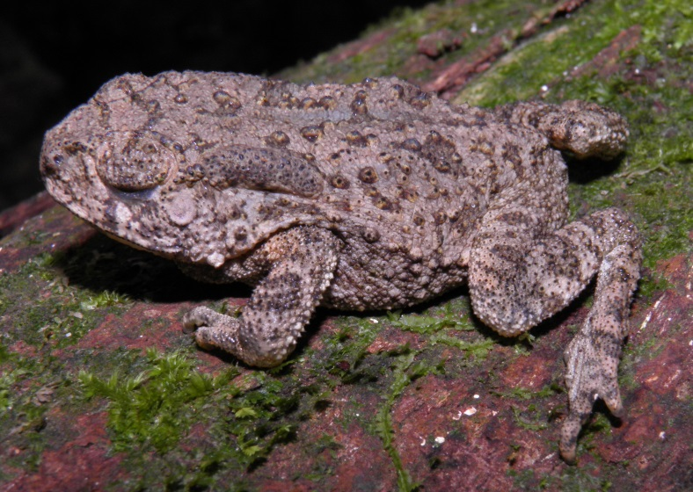

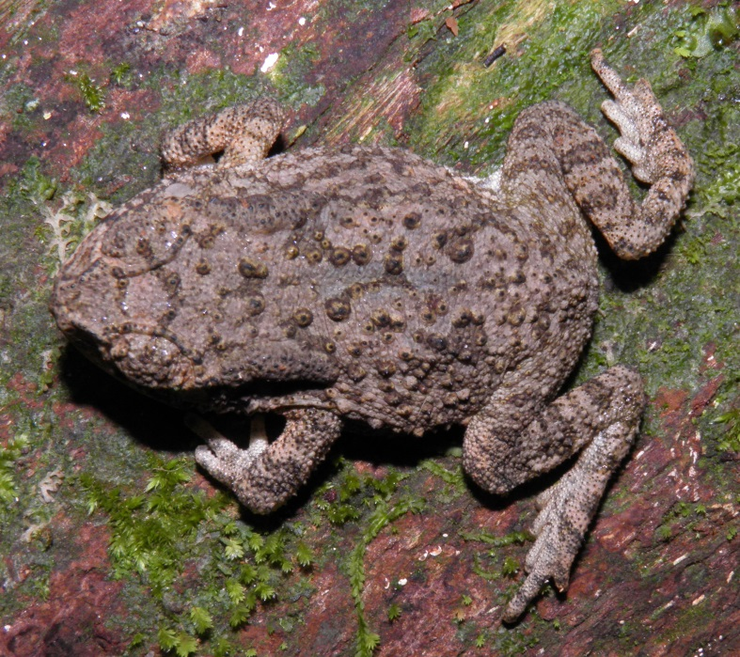
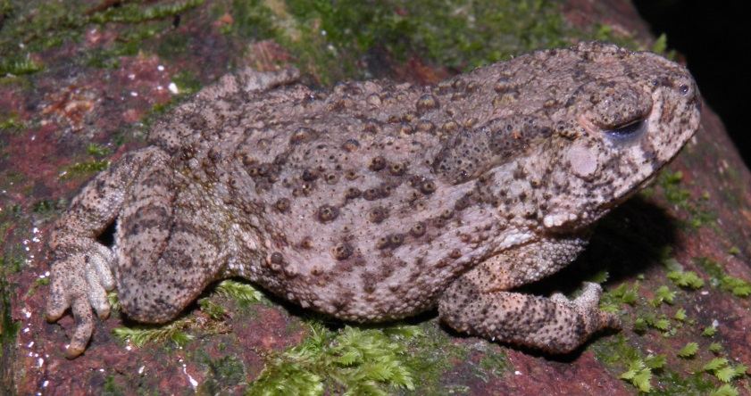

I am not completely convinced now that we ever saw Hylarana millet in this survey. Hylarana millet is smaller than H. attigua and has larger toepads on the fingers. It also has more distinctly patterened hidden areas of thigh and calf. I cannot tell from Randy’s picture of H. milleti which animal is illustrated. All my pictures of measured animals are from the other side. Here are some images of the only one that I now I think is really H. milleti based on toepad size and overall size:
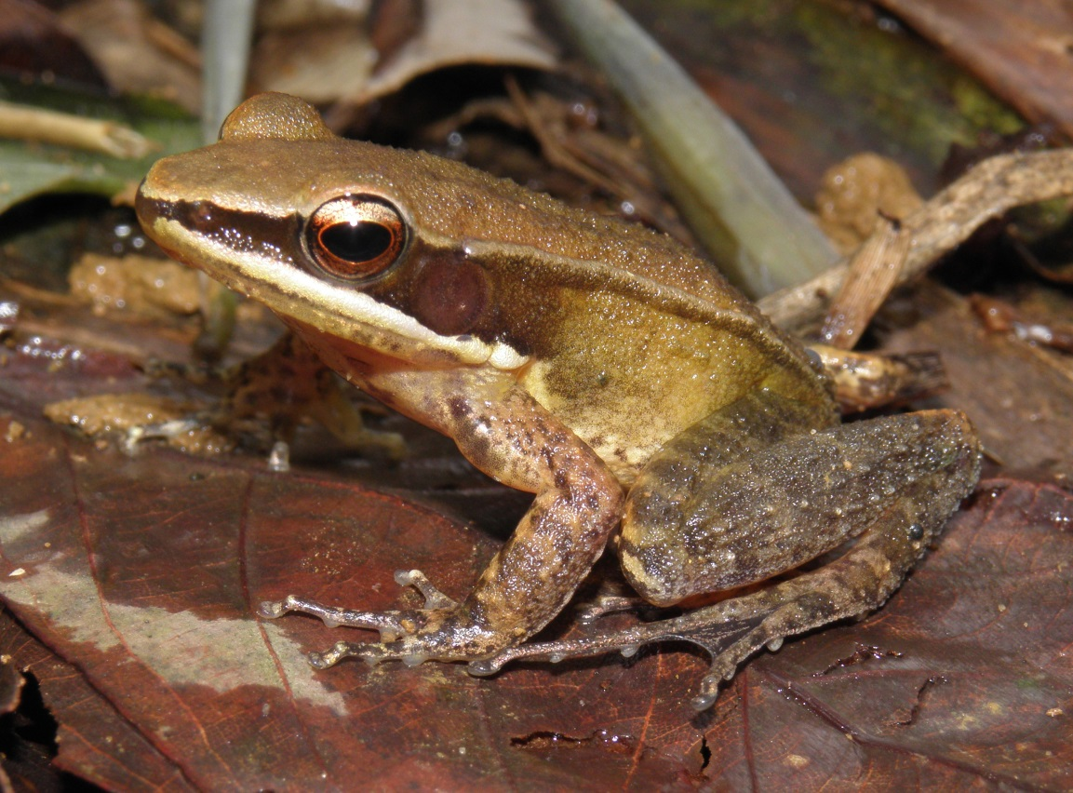
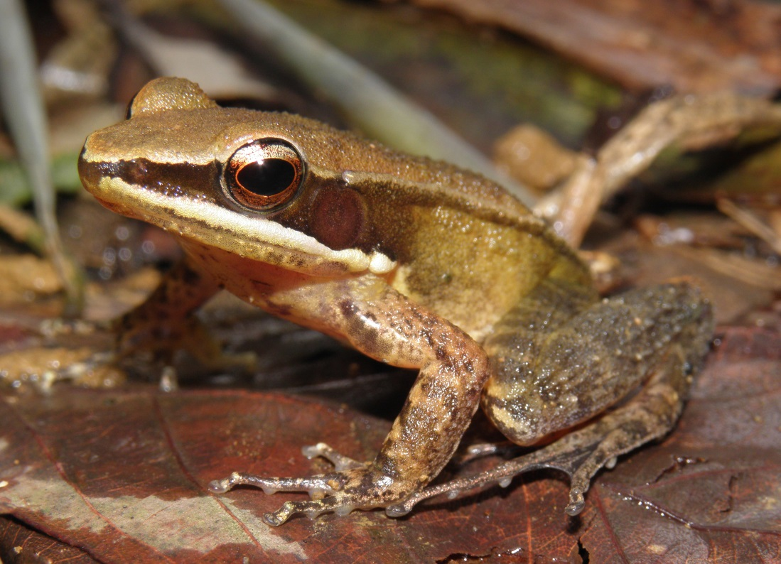
I re-read the paper describing three new species of small Microhyla and think we had all three (M. marmorata, M. pulverata, and M. nanapolluxa).
I am not sure at all how to tell the Odorrana species apart. I seemingly labelled most of my green Odorrana from 2012 as O. morafkai. I do not seem to have pictures of the one you included as O. morafkai; but I do have some of that very large thing we got in 2012. It does not seem to be colored as in the one you used in having a plane-colored groin. Here are a couple of that one:

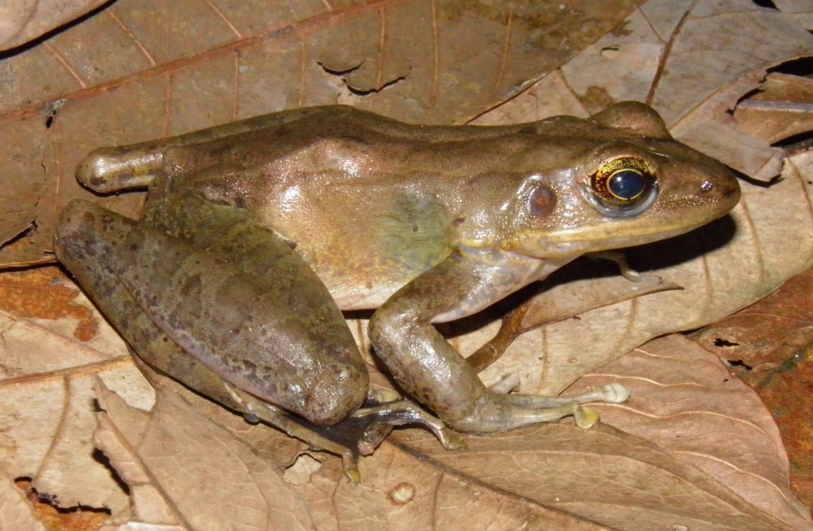
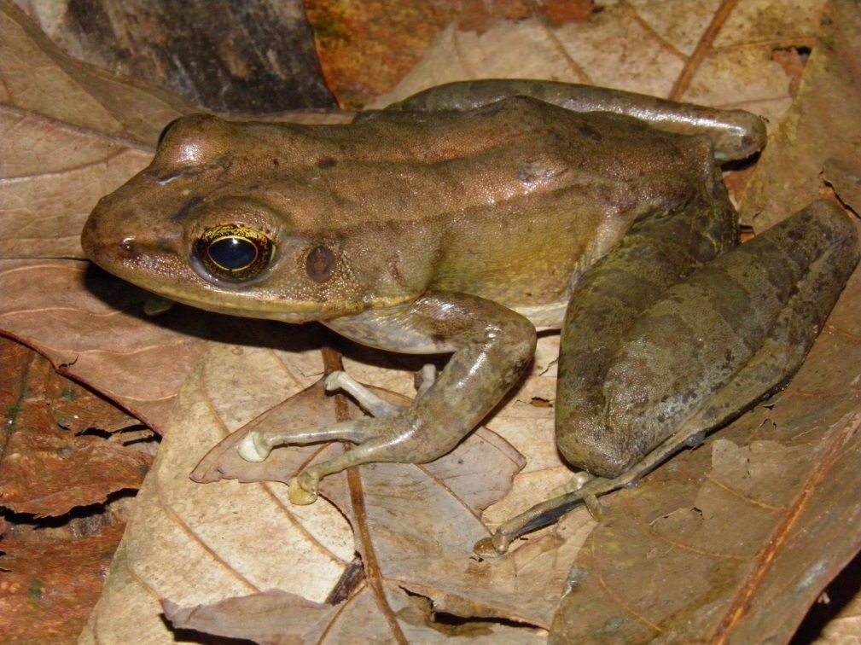
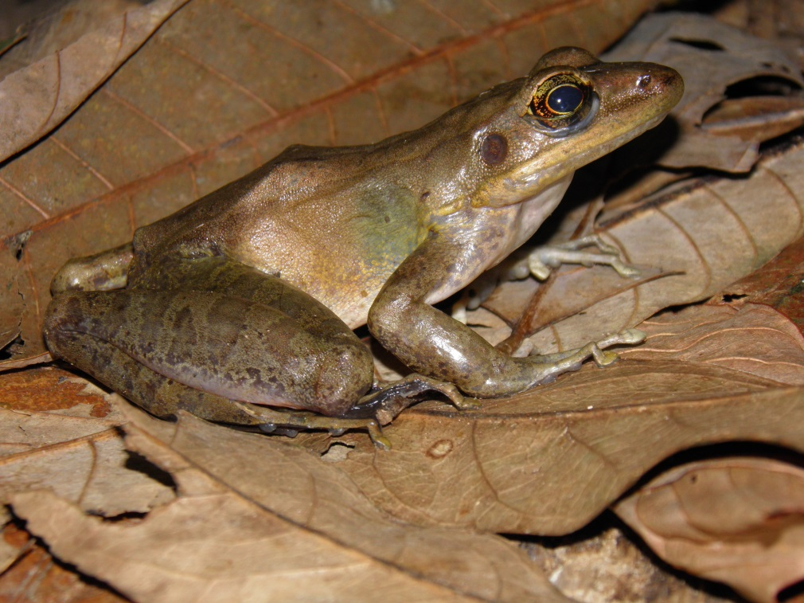
Do any of us remember our conclusions about how to tell the differences between Raorchestes gryllus, Philautus banaensis, and Kuixalus verrucosus? I seem to recall something about the perianal warts and the fringes on the limbs; but not the specifics.
I read most of the paper by Rowley et al. (2011) describing two new Theloderma. I think it most likely that we had both T. truongsonensis (completely smooth and light dorsum) as well as T. nebulosum (some tubercules and light dorsum with darker markings. I thought there was a problem way back when but forgot. The one you have illustrated is T. nebulosum. Here are some images of T. truongsonensis:
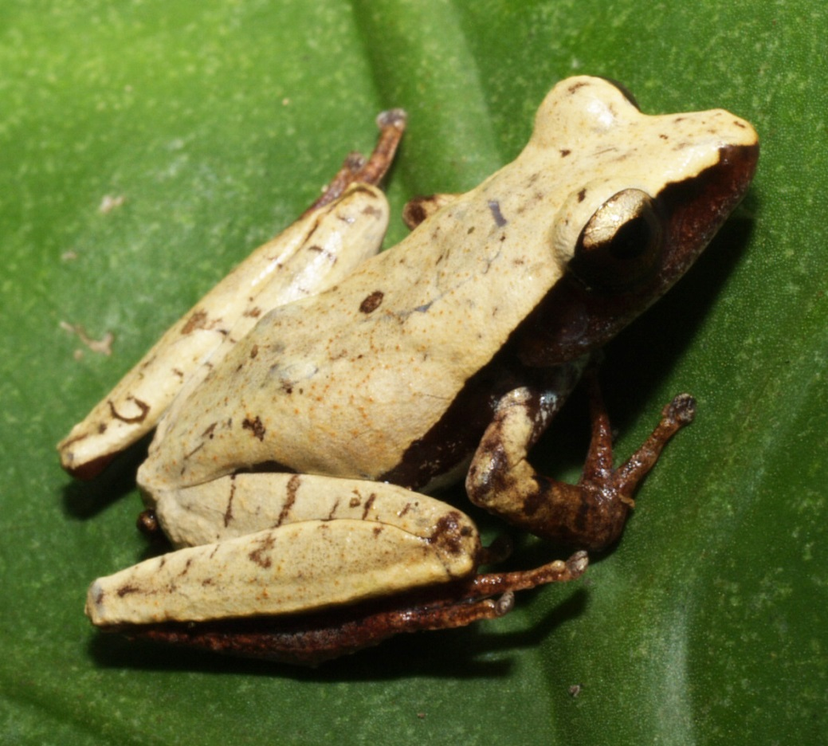
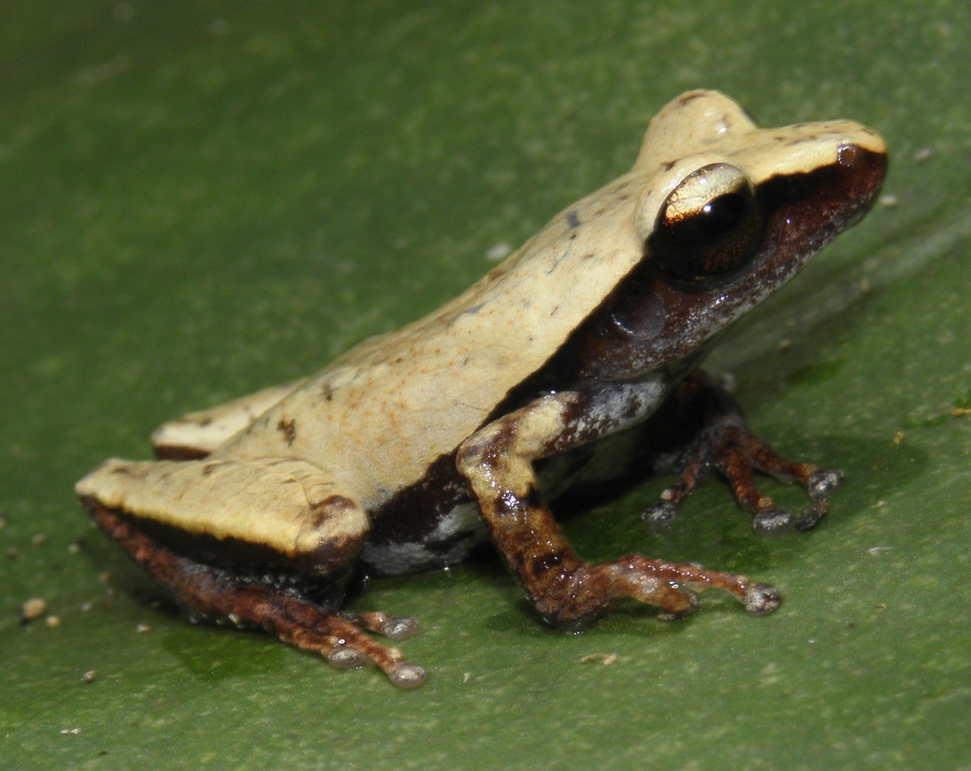

Xenophrys species
We did get one smaller Xenophrys species with larger horns and broader heads. I doubt very strongly that this is a juvenile of X. major. Could this be a baby Brachytarsophys?
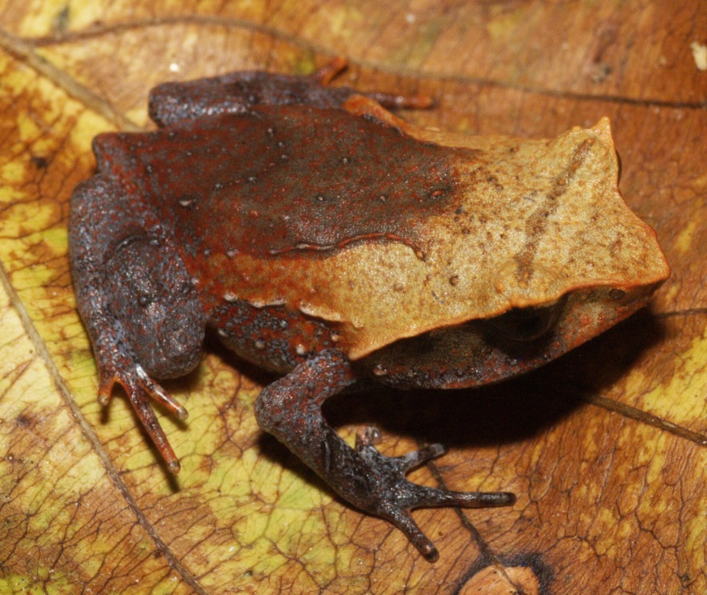
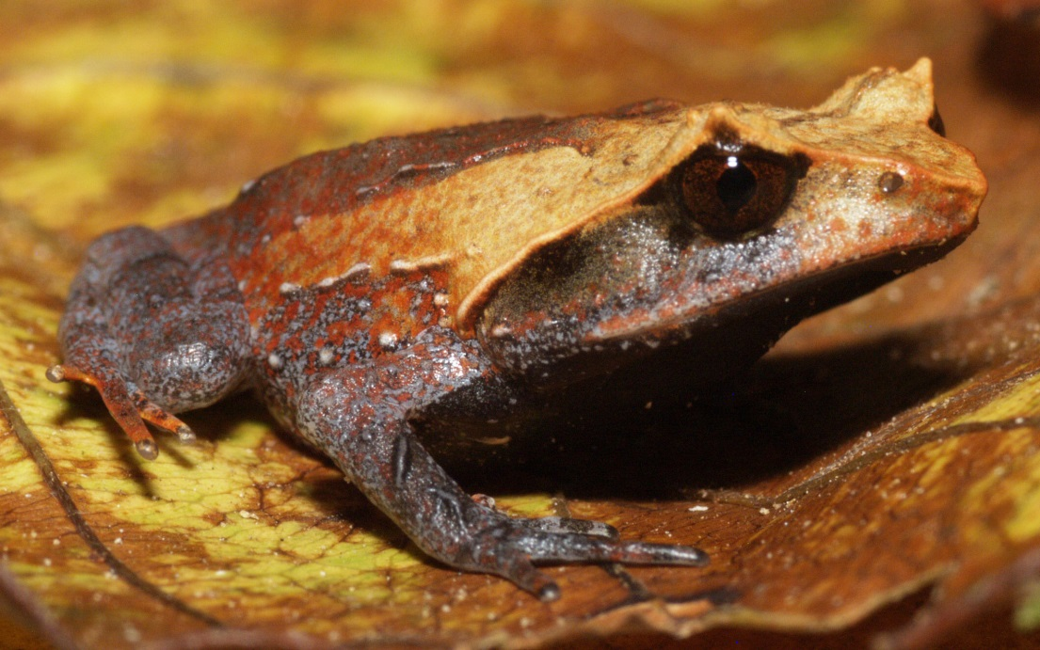

Toe shape, overall habitus, coloration, and distribution of the dorsolateral ridges are completely different from X. major.

Reference for Sphenomorphus sheai:

A new species of Sphenomorphus Fitzinger, 1843 (Squamata: Sauria: Scincidae) from
Vietnam. Truong Quang Nguyen, Khoi Vu Nguyen, Robert Wayne Van Devender,
Michael Bonkowski & Thomas Ziegler. Zootaxa 3734 (1): 056-062. 2013.

A couple more images:
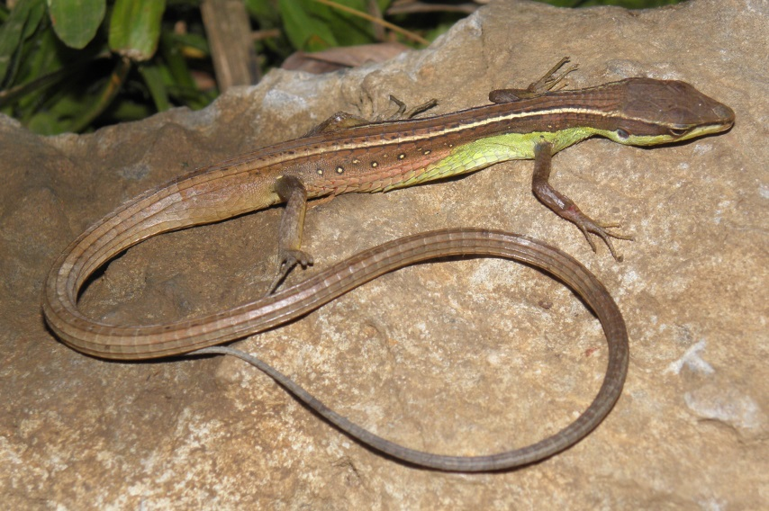
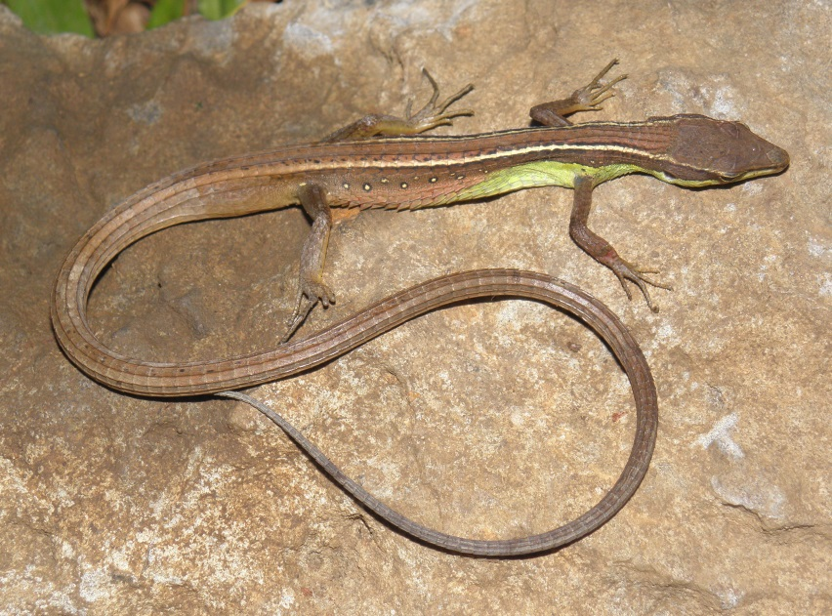
I could find no pictures or records of Scincella melanosticta from Quang Ngai and the picture you use here seems to be from Nui Chua.
I am sending along some pages from my first reptile PowerPoint from Ba To.
